

# RYANA CALENDARS

**Supervisor:** *LÊ TUẤN XUYÊN*

**Semester:** *01*

**Batch No:** *T1.2401.E0*

**Group No:** *01*

|  |  |  |
| --- | --- | --- |
| **Order:** | **Full name** | **Roll No.** |
| *1.* | *VI QUỐC NHẪN* | *Student1545472* |
| *2.* | *ĐỖ NGUYỄN THIỆN HOÀNG* | *Student1545463* |
| *3.* | *NGUYỄN MINH PHÚ* | *Student1548609* |
| *4.* | *HÀ MỸ NGỌC* | *Student1545743* |
| *5.* | *NGÔ THỊ CẨM NHUNG* | *Student1545461* |

***Month****: 04* ***Year****: 2024*



This is to certify that

**Mr. VI QUỐC NHẪN Mr. ĐỖ NGUYỄN THIỆN HOÀNG Ms. NGUYỄN MINH PHÚ**

**Ms. HÀ MỸ NGỌC**

**Ms. NGÔ THỊ CẨM NHUNG**

Have successfully Designed & Developed

**RYANA CALENDARS**

Submitted by:

**Mr. VI QUỐC NHẪN**

Date Of Issue:

**17/04/2024**

Authorized Signature:

**Mr. VI QUỐC NHẪN**

# Content

Content 3

Acknowledge 5

Synopsis 6

Problem Definition 7

Customer Requirements Specifications 8

Site Map of The Project 10

I. Home Pages 11

II. Products 13

1. Search Product 13

2. All Products page 15

2.1. Select Sort 19

2.2. Filter by category 21

2.3. Filter by price 21

3. Product Detail Page 22

4. Cart Page 23

5. Checkout Page 24

6. Calendar Page 28

7. Notebook Page 30

III. Download 32

IV. Contact Page 36

V. News Page and News Page Detail 37

1. News Page 37

2. News Page Content 40

VI. About Us Page 42

VII. Responsive Web Page 43

1. Home Page 43

1.1. Mobile 43

1.2. Tablet 44

1.3. Laptop 45

2. News Page 45

2.1. Mobile 45

2.2. Tablet 46

2.3. Laptop 47

3. All Product, Calendar, Notebook Page 47

3.1. Mobile 47

3.2. Tablet 48

3.3. Laptop 48

4. Contact Page 49

4.1. Mobile 49

4.2. Tablet 50

4.3. Laptop 51

Task Sheet 52

# Acknowledge

As we understand that the eProject is a step-by-step learning environment that closely simulates the classroom and Lab-based learning environment into actual implementation. It is a project implementation at your fingertips!! An electronic, live juncture on the machine that allows you to.

* Practice step by step i.e. laddered approach.
* Build a larger more robust application.
* Usage of certain utilities in applications designed by user.
* Single program to unified code leading to a complete application.
* Learn implementation of concepts in a phased manner.
* Enhance skills and add value.
* Work on real-life projects.
* Give a real-life scenario and help to create applications more complicated and useful.
* Mentoring through email support.

First of all, I would like to thank India Aptech for allowing my team to work on this fantastic eProject. We had a great experience with eProject this time.

Next, we would like to express my special thanks to our mentor, Mr. Le Tuan Xuyen for the time and effort that she provided throughout the project. Your helpful advice and suggestions were beneficial to us during the completion of the project. In this respect, we are forever grateful to you.

Besides several mistakes we made in the project, we hope to have more opportunities to widen our knowledge in the web-developing world.

We will try to continue to learn and improve ourselves even more in the future.

Yours Sincerely, Team Group 01.

# Synopsis

The Objective of this program we aim is to give a sample project to work on real- life projects. These applications help us build a larger more robust application.

The objective is not to teach us HTML/JavaScript but to provide us with a real-life scenario and help us create basic applications using the tools.

Hence, we can revise the chapters before we start with the project.

This project is meant for students like us who have completed the module of ReactJS. These programs should be done in the Lab sessions with the assistance of the faculty if required.

It is very essential for us that will have a clear understanding of the subject. We think we should go through the project and solve the assignments as per the requirements given.

And get back [***eprojects@aptech.ac.in***](mailto:eprojects@aptech.ac.in) as the assigned schedule.

# Problem Definition

Ryana Calendars is selling various Calendars and Diary products. The company advertises by distributing the pamphlets, advertising on television and so on. Due to rapid development in internet field, the company decides to launch a website where people will get all the information about the various products available with them easily.

The website is to be developed for the Windows Platform using HTML5, ReactJS, Bootstrap and Geolocation. The site should work well in all leading browsers including Chrome, IE, Firefox etc.

**Requirement Specification:**

The Web site is to be created based on the following requirements.

1. The Home Page should be created making use of Sections with a suitable logo
2. The site should display a menu which will contain the options for brief introduction about the various products available, location of the shop and any other information if required.
3. The information should be categorized according to different type of products like if a User wants to see only ‘Journal’ then he click on a Link/button/menu etc and he will see different type of Journal. Similarly for ‘Calendars’, ‘Diaries’ and other products
4. When a user selects any product type, a list of products for that product type will be displayed.
5. A brief summary of features of individual products should be displayed on the Web Page along with the product but detailed Features should be stored in Individual Word documents which can be downloaded or viewed by the User who wishes to see the same.
6. Price List should be available for download.
7. There should be a “Contact Us” page which will have the Address of the Company which is as follows and the mail address which when clicked will invoke the local mail client from where they can send an email.

# Customer Requirements Specifications

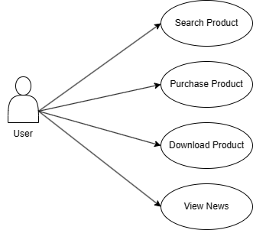

*Ryana Calendars Use Case diagram.*

**Hardware/ software requirement:**

**Software:**

* MS Edge / Chrome / FireFox
* Visual Studio Code

**Language:**

* JavaScript / CSS

**Technology:**

* React / react-router-dom /
* Bootstrap
* Framer motion
* react-paypal-js
* jQuery
* html2pdf.js / jspdf / html2canvas
* fortawesome
* Swiper

**Hardware:**

* A minimum computer system that will help you access all the tools in the courses is a Pentium 166 or better
* 64 Megabytes of RAM or more

# Site Map of The Project

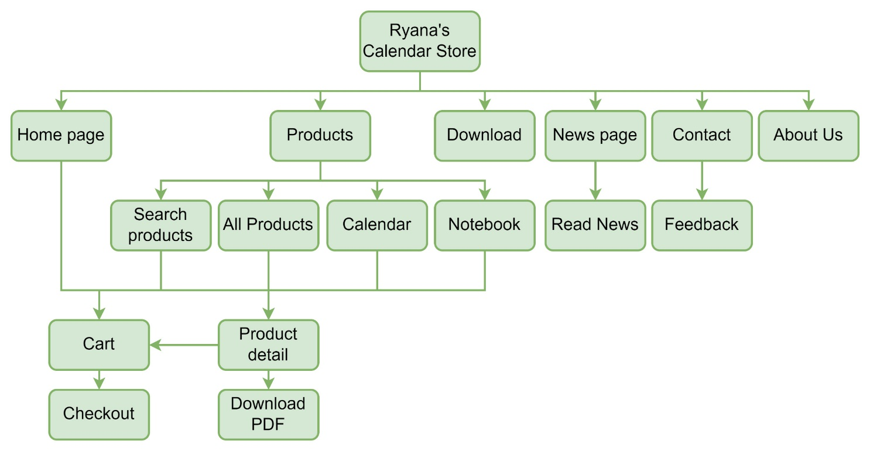

## Home Pages

The home page is used to view product lists by categories.

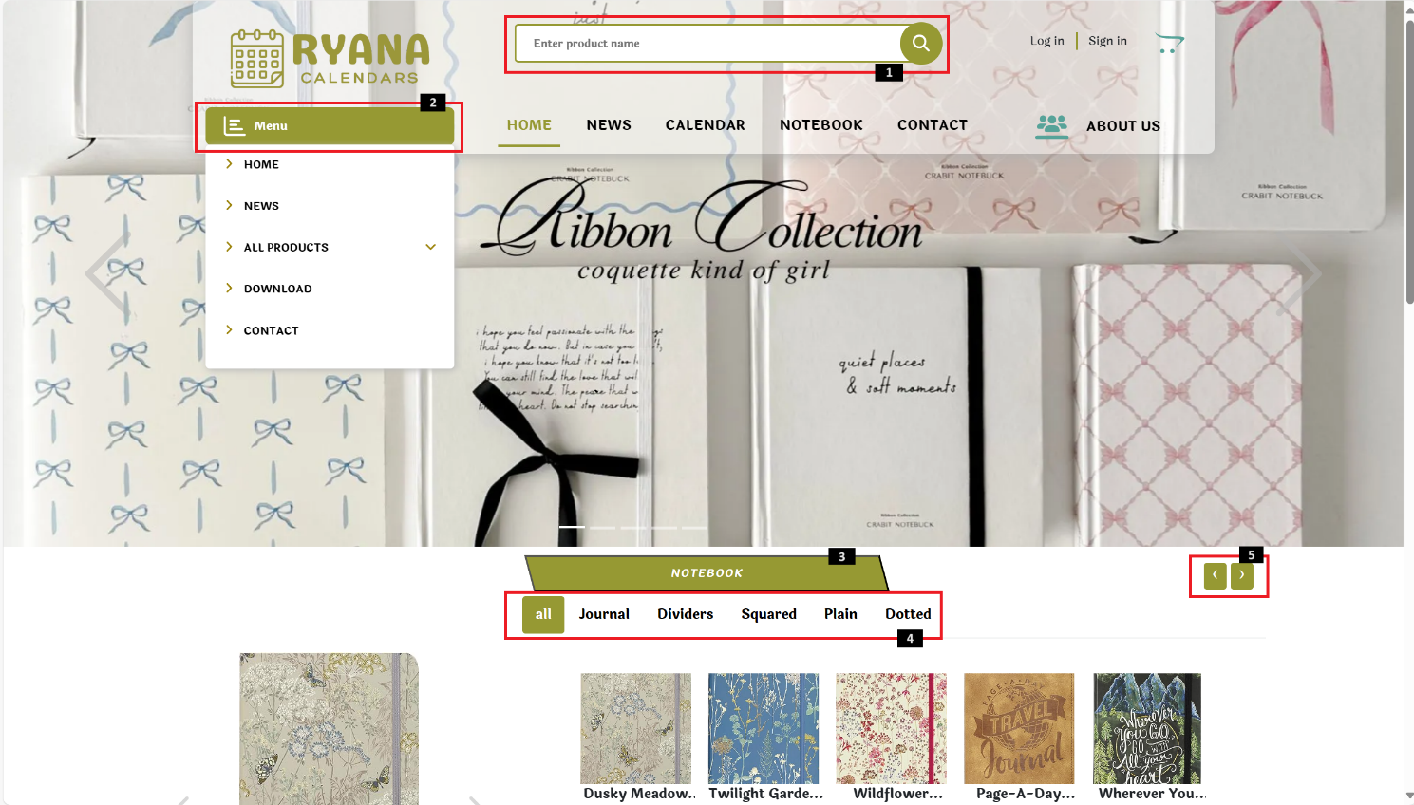

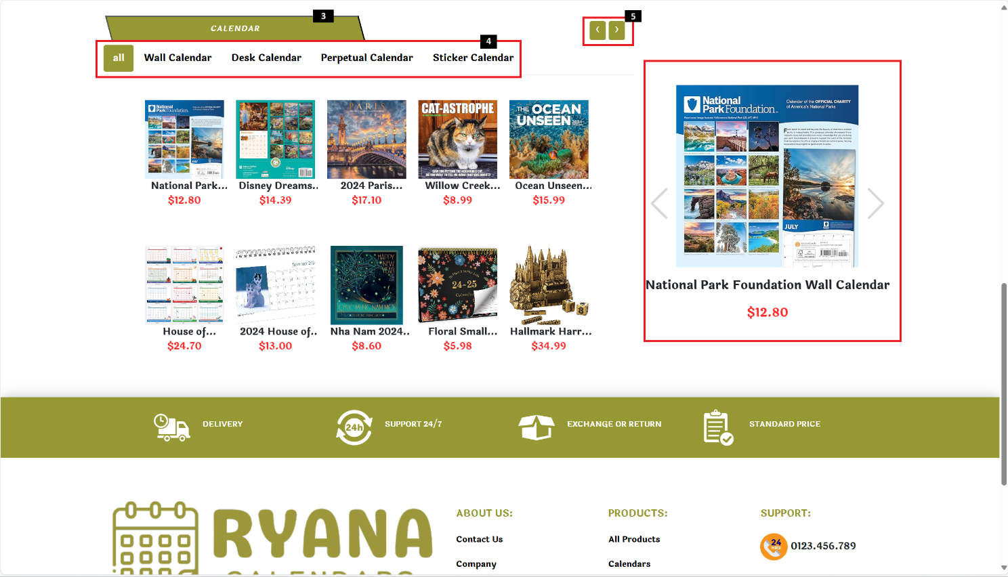

|  |  |  |  |
| --- | --- | --- | --- |
| **No** | **Type** | **Validation** | **Action** |
| 1 | Text |  | Enter the product name and automatically navigate to search page |
| 2 | Click |  | Show all options of Menu |
| 3 | Click |  | Navigation to Notebook, Calendar page |
| 4 | Click |  | Show products by categories |
| 5 | Click |  | Show more products |
| 6 | Click |  | Carousel to see another product, Navigation to Product Details |

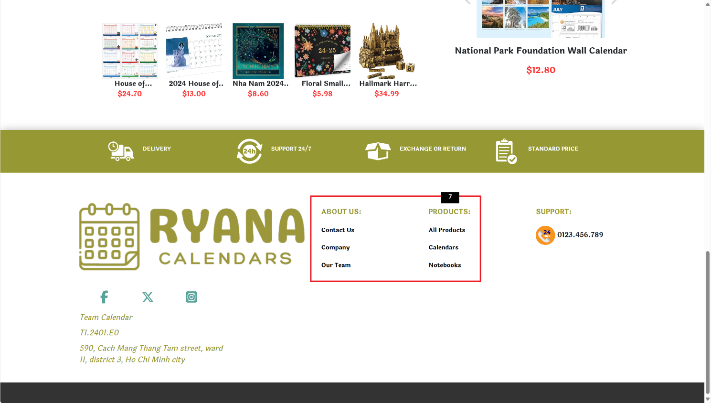

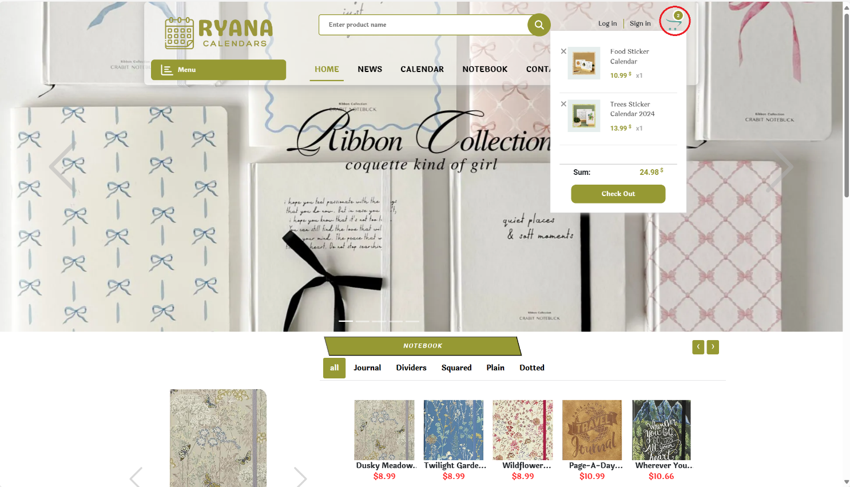

|  |  |  |  |
| --- | --- | --- | --- |
| **No** | **Type** | **Validation** | **Action** |
| 7 | Click |  | Navigation to Contact, About Us, All Product, Calendar and Notebook Page |
| 8 | Hover |  | Show list products in cart. |

## Products

Search, view, select products, quantities and place orders.

### Search Product

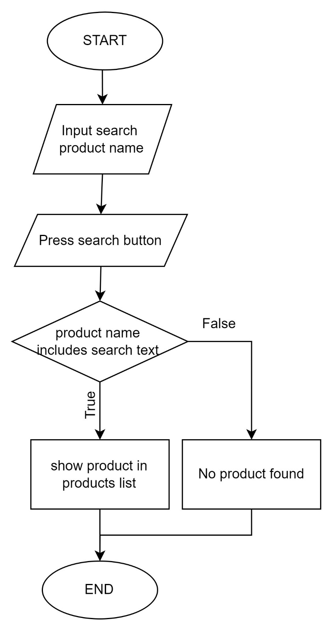

*Flowchart of Search product function.*

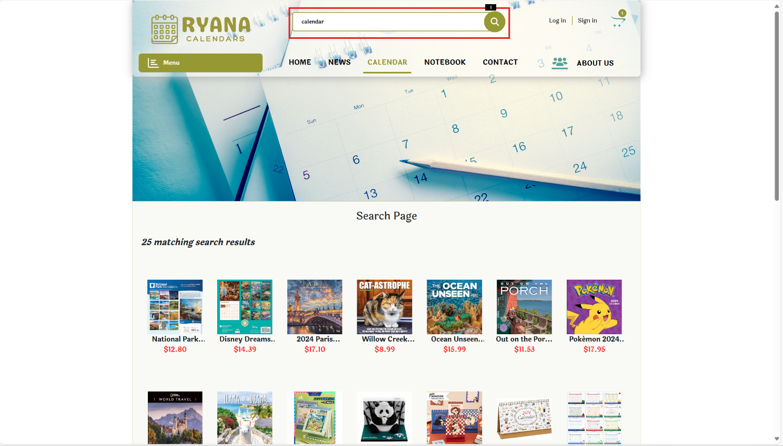

Enter a product name to display the entire product that contains the entered character.

### All Products page

The All Products page is used to view all the store's products, can be searched by name, sorted by category, and sorted by price.

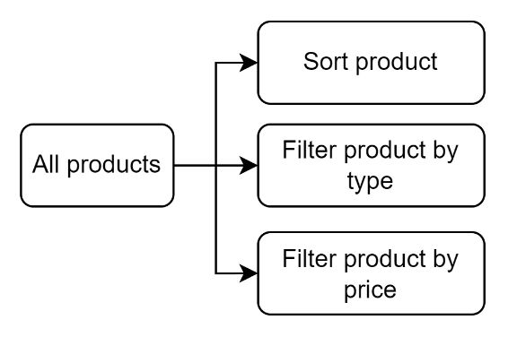

*All Products’ diagram.*

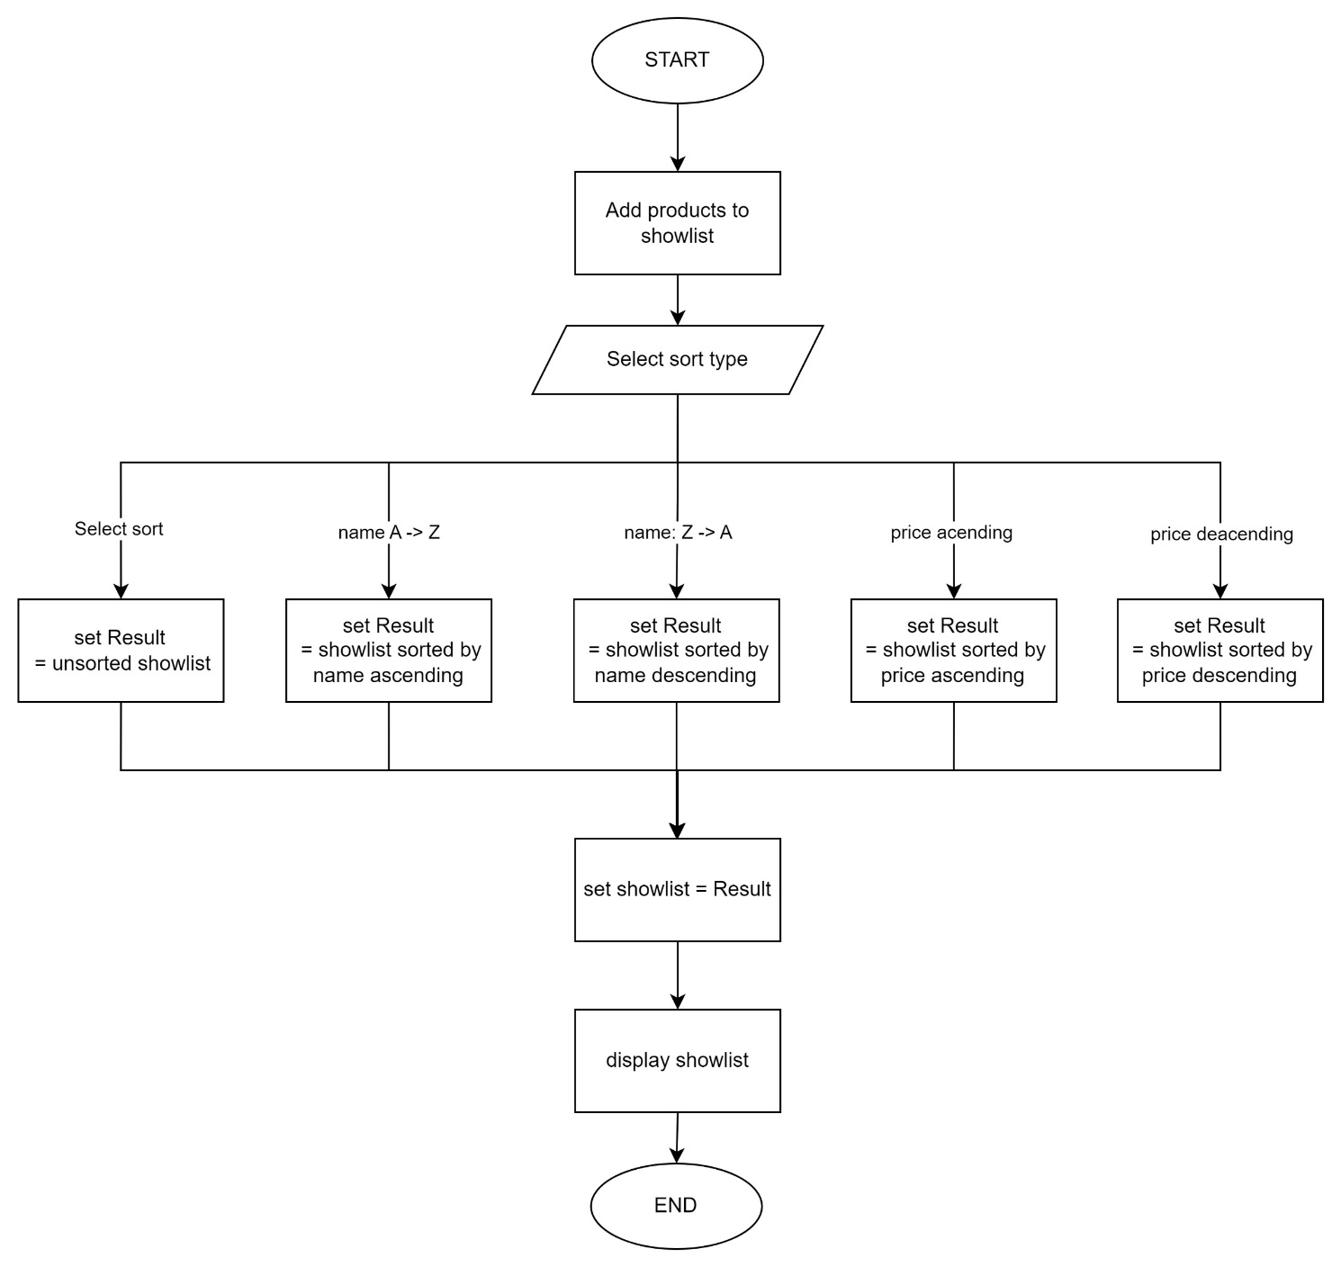

*Flowchart of sort by select type function.*

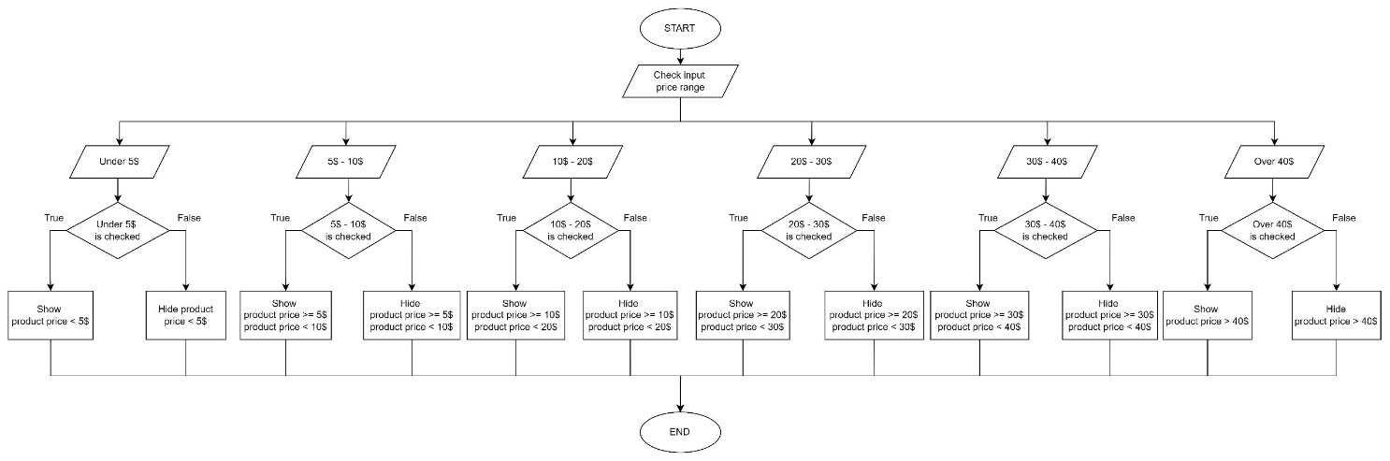

*Flowchart of Filter by price function.*

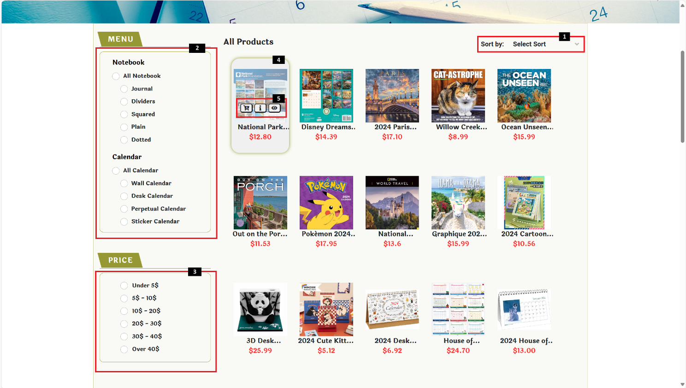

|  |  |  |  |
| --- | --- | --- | --- |
| **No** | **Type** | **Validation** | **Action** |
| 1 | Hover |  | Show sort type |
| 2 | Click |  | Sort by category |
| 3 | Click |  | Sort by price |
| 4 | Hover/Click |  | Show 3 button/Navigation to Product detail |
| 5 | Click |  | * Add to cart * Navigation to Product detail modal * Navigation to Product detail page |

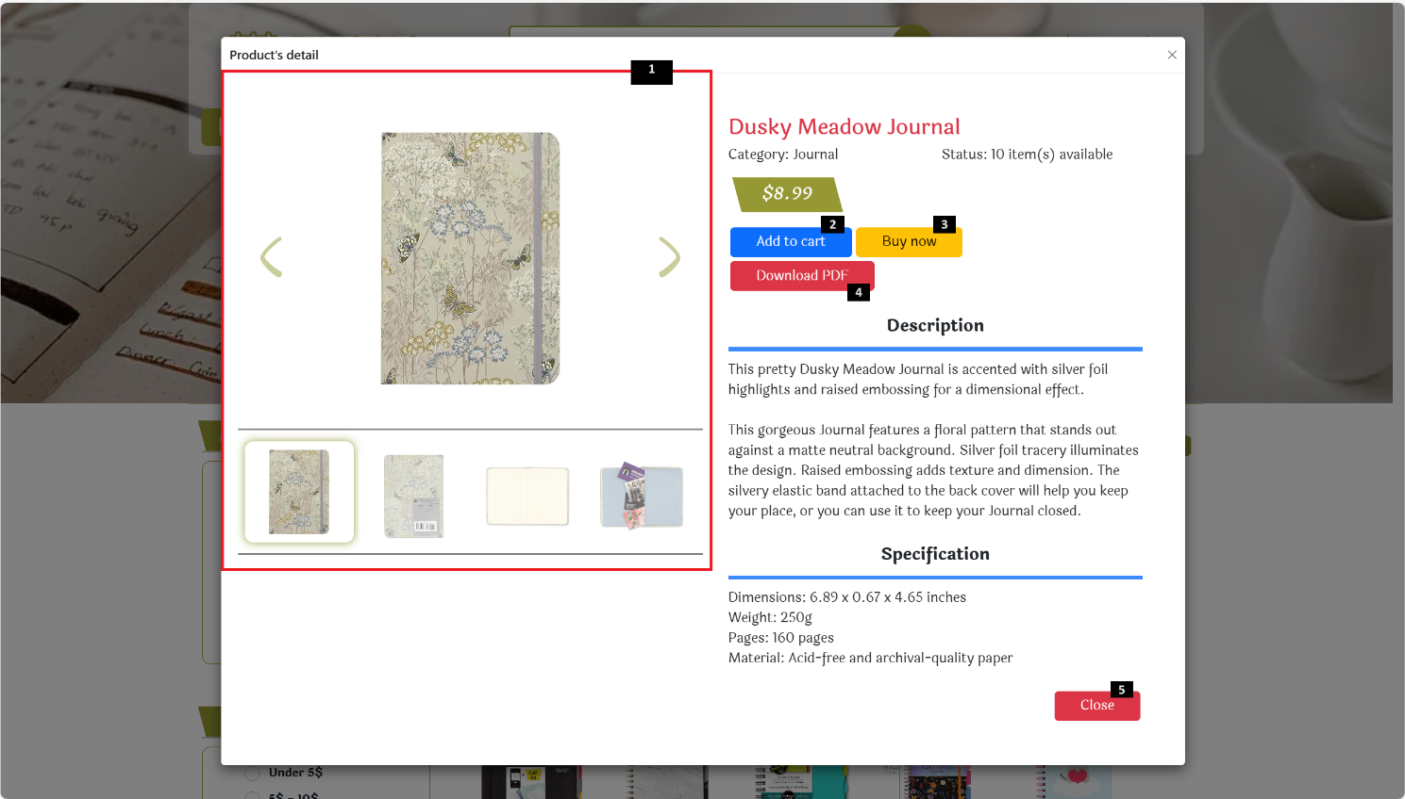

*Product detail modal image.*

|  |  |  |  |
| --- | --- | --- | --- |
| **No** | **Type** | **Validation** | **Action** |
| 1 | Click |  | Show more image of product |
| 2 | Click |  | Add to cart |
| 3 | Click |  | Navigation to Cart page |
| 4 | Click |  | Download PDF |
| 5 | Click |  | Close modal |

#### Select Sort

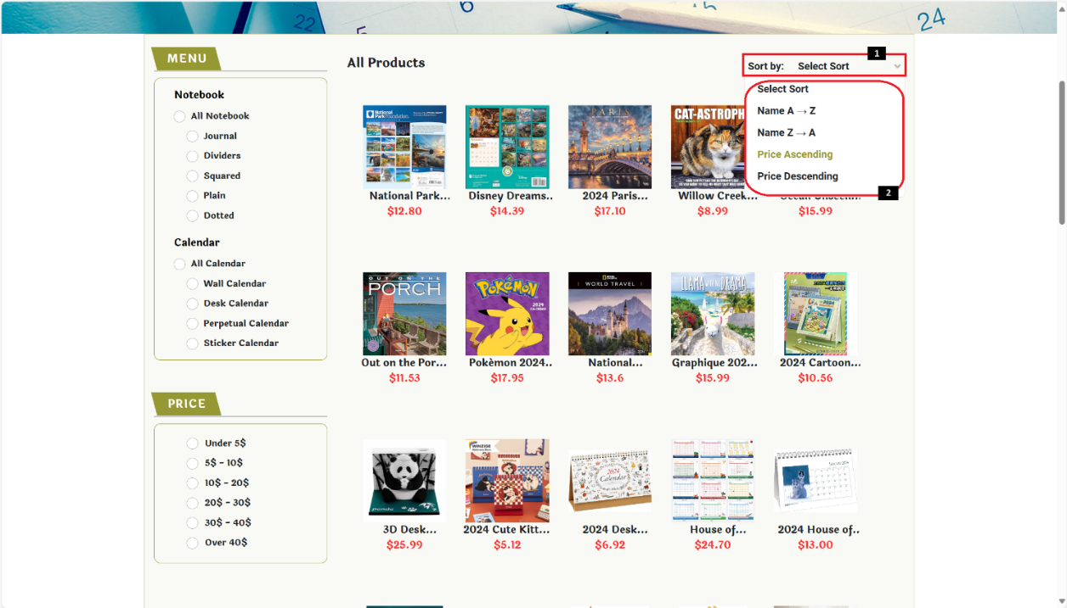

|  |  |  |  |
| --- | --- | --- | --- |
| **No** | **Type** | **Validation** | **Action** |
| 1 | Hover |  | Show sort type |
| 2 | Click |  | Show results sorted by type |

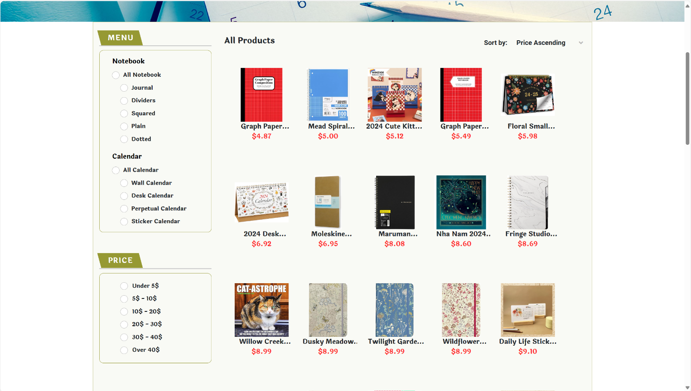

*Image of results sorted in ascending price style function.*

#### Filter by category

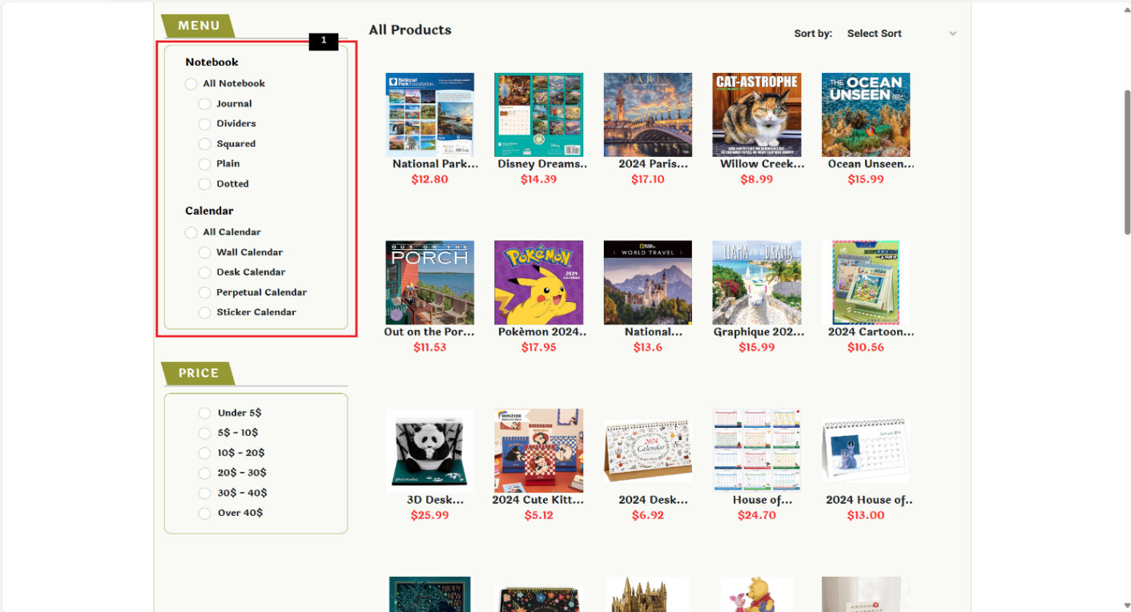

Click on the check box to show results sorted.

#### Filter by price

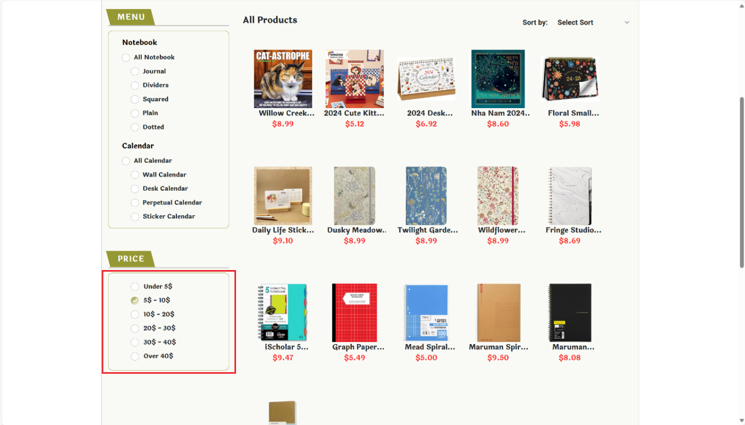

Click on the check box to show results sorted.

### Product Detail Page

The Product detail page is used to view product details: images, description, …

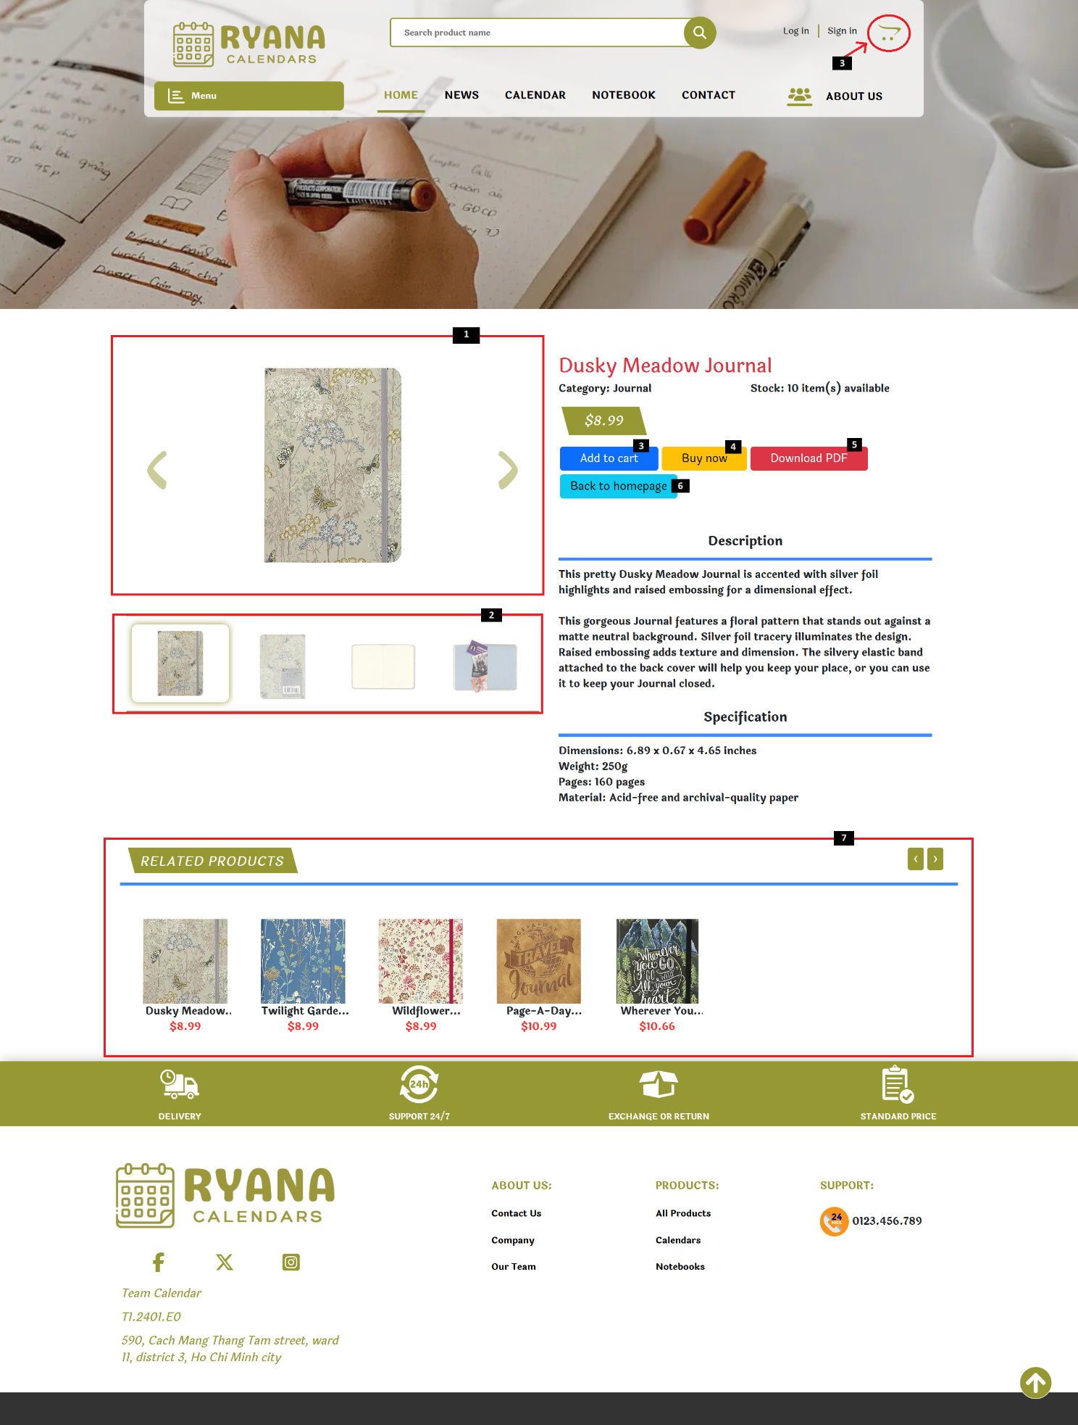

|  |  |  |  |
| --- | --- | --- | --- |
| **No** | **Type** | **Validation** | **Action** |
| 1 | Click |  | Show more product images |
| 2 | Click |  | Show more product images |
| 3 | Click |  | Add product to cart |
| 4 | Click |  | Navigation to Cart page |
| 5 | Click |  | Download detail of current product |
| 6 | Click |  | Navigation to Homepage |
| 7 | Click |  | Navigation to another product detail |

### Cart Page

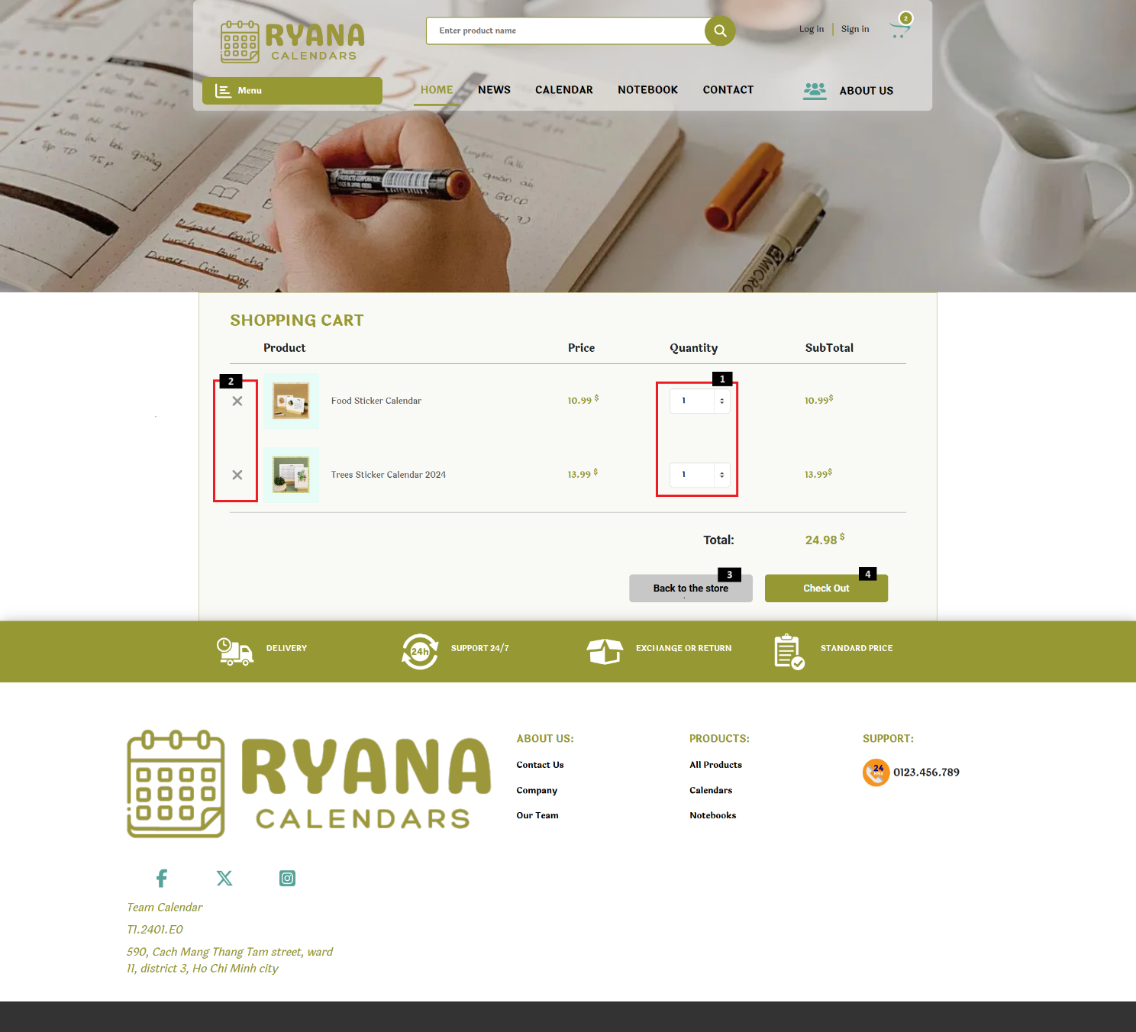

The Cart page is used to view the shopping cart, change quantities, or delete products.

|  |  |  |  |
| --- | --- | --- | --- |
| **No** | **Type** | **Validation** | **Action** |
| 1 | Click/Text |  | -Press ‘🢑 to increase’ or ‘🢓 to decrease’ the quantity.  -Enter the quantity to be purchased. |
| 2 | Click |  | Delete product |
| 3 | Click |  | Navigation to Home page |
| 4 | Click |  | Navigation to Checkout page |

### Checkout Page

The Checkout page is used to fill in consignee information, delivery method, and payment method. Then confirm the order.

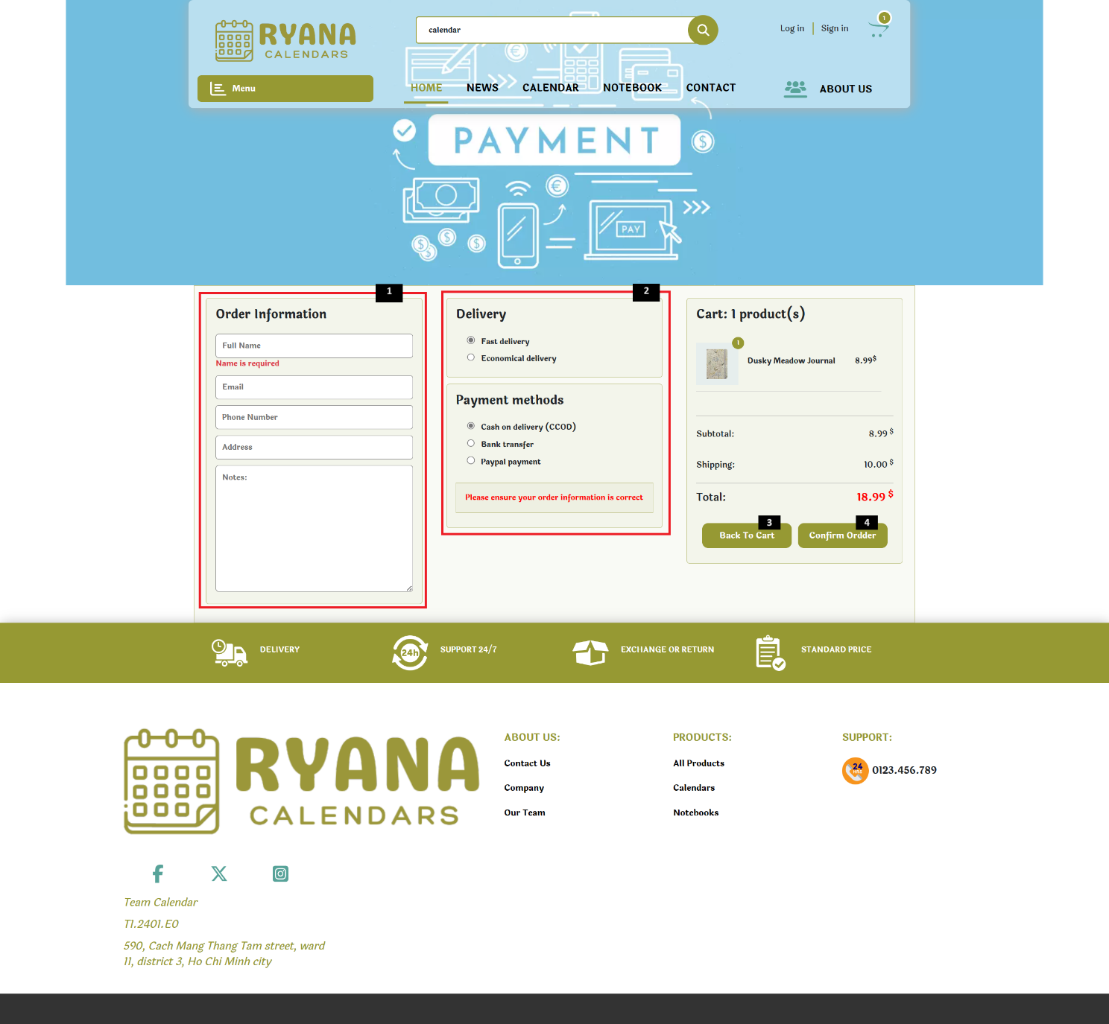

|  |  |  |  |
| --- | --- | --- | --- |
| **No** | **Type** | **Validation** | **Action** |
| 1 | Text | Name is required.  Email is required, and improper formatting.  Phone number is required, and improper formatting.  Address is required. | Enter information: Name, Email, Phone number, Address, and Leave notes if needed. |
| 2 | Click | Fill all information to choose method of delivery and payment | Choose your method of delivery and payment. |
| 3 | Click |  | Navigation to cart page |
| 4 | Click |  | Confirm order |

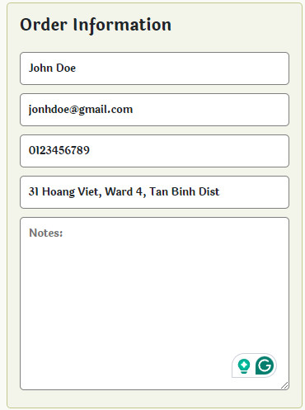

*Information’s example*

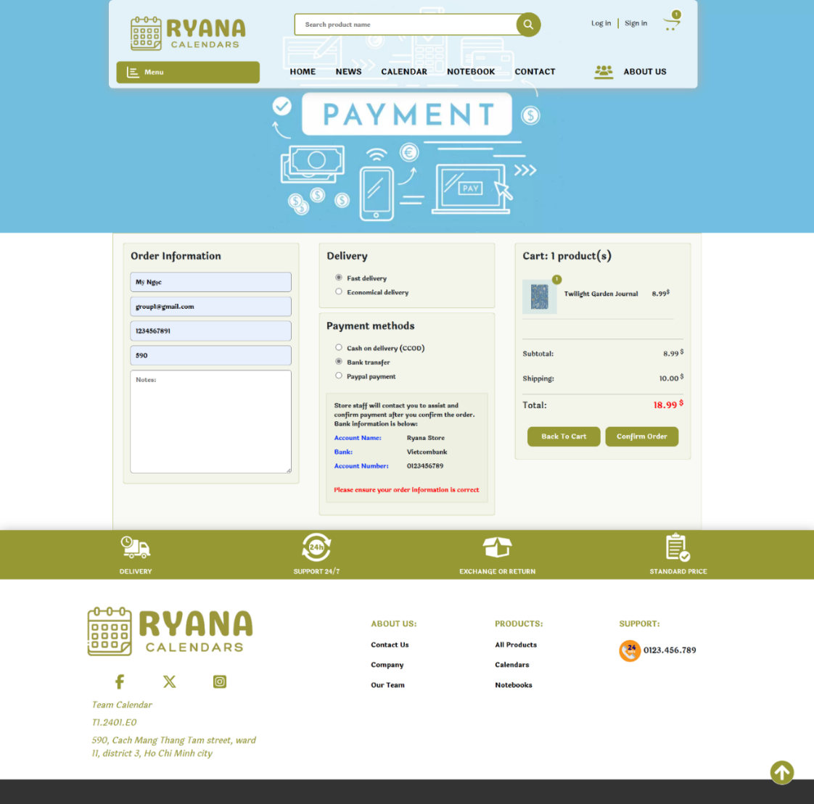

*Example of bank transfer method*

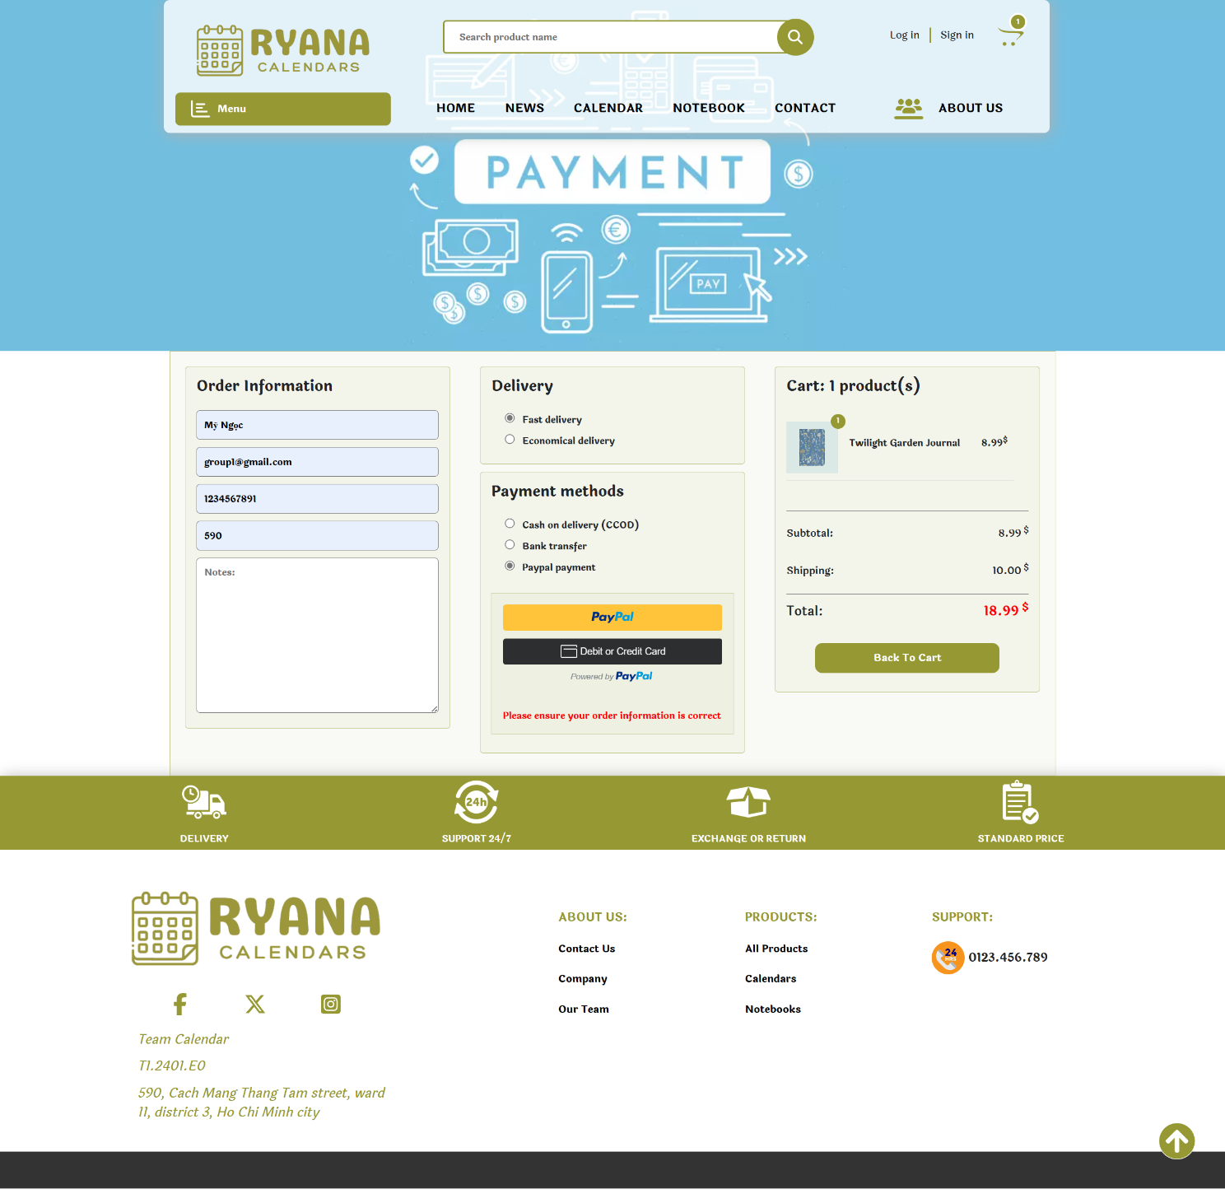

*Example of Paypal and Credit card method.*

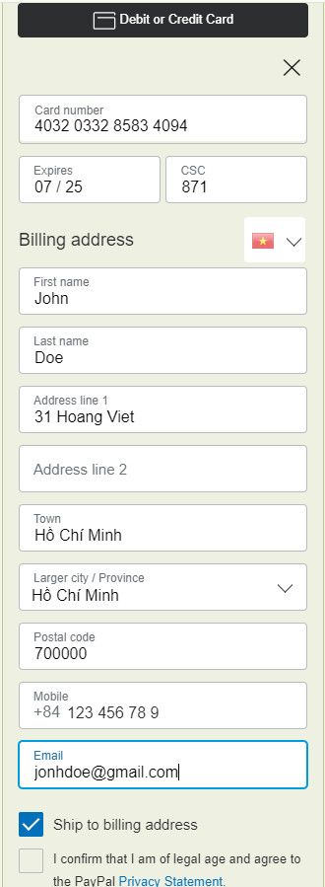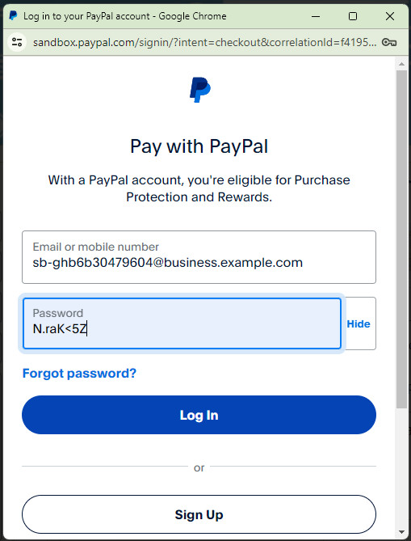

### Calendar Page

The Calendar page is used to view all the calendar's products, can be searched by name, sorted by category, and sorted by price.

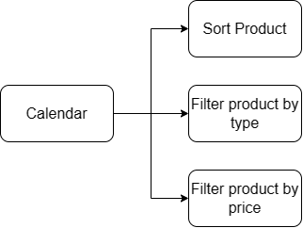

*Calendar page diagram.*

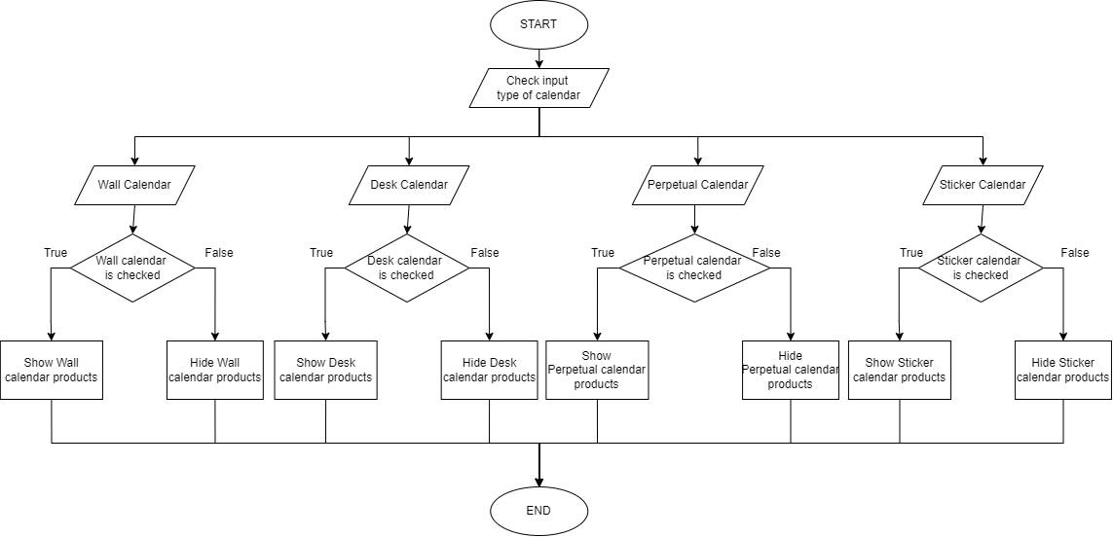

*Calendar page flowchart.*

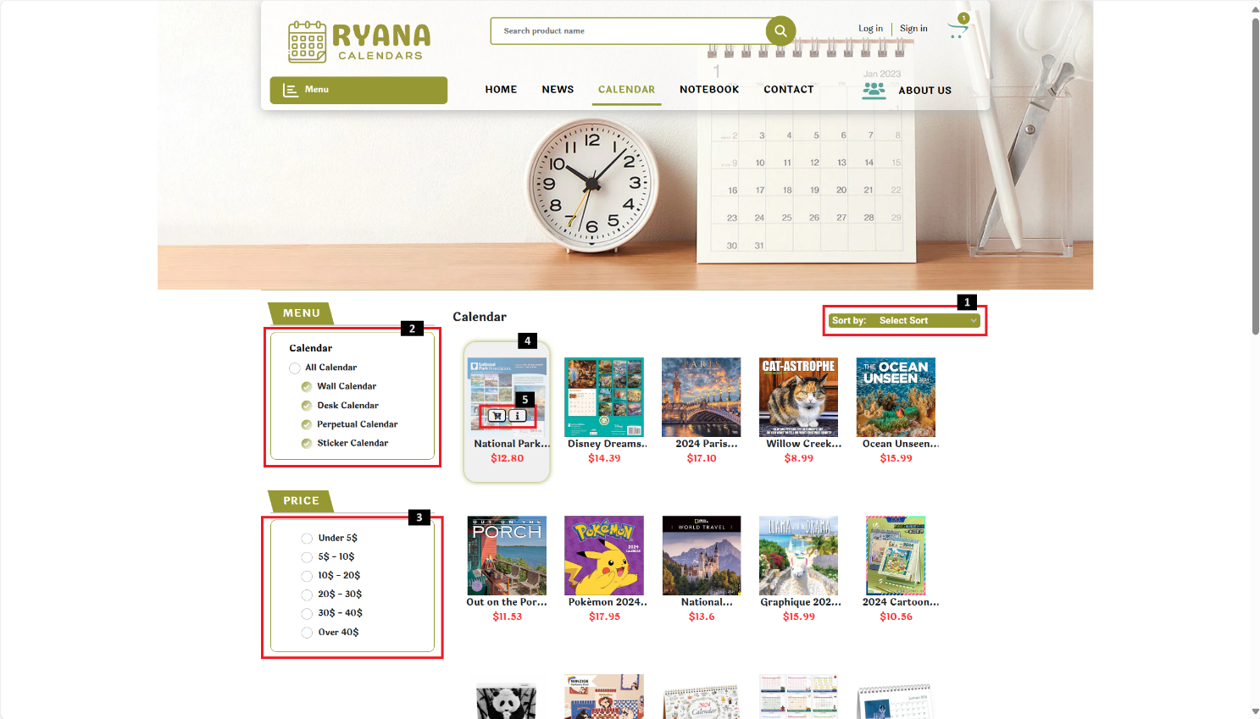

|  |  |  |  |
| --- | --- | --- | --- |
| **No** | **Type** | **Validation** | **Action** |
| 1 | Hover |  | Show sort type |
| 2 | Click |  | Sort by Calendar’s category |
| 3 | Click |  | Sort by price |
| 4 | Hover/Click |  | Show 2 button/Navigation to Product detail |
| 5 | Click |  | * Add to cart * Navigation to Product detail modal |

### Notebook Page

The Notebook page is used to view all the notebook's products, can be searched by name, sorted by category, and sorted by price.

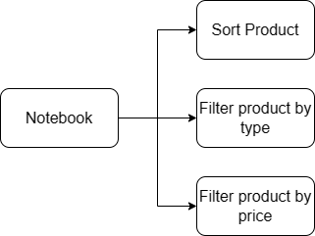

*Notebook page diagram.*

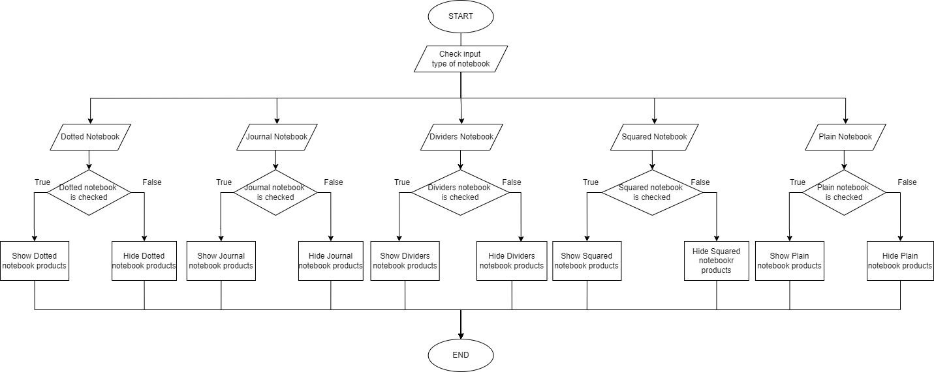

*Notebook page flowchart.*

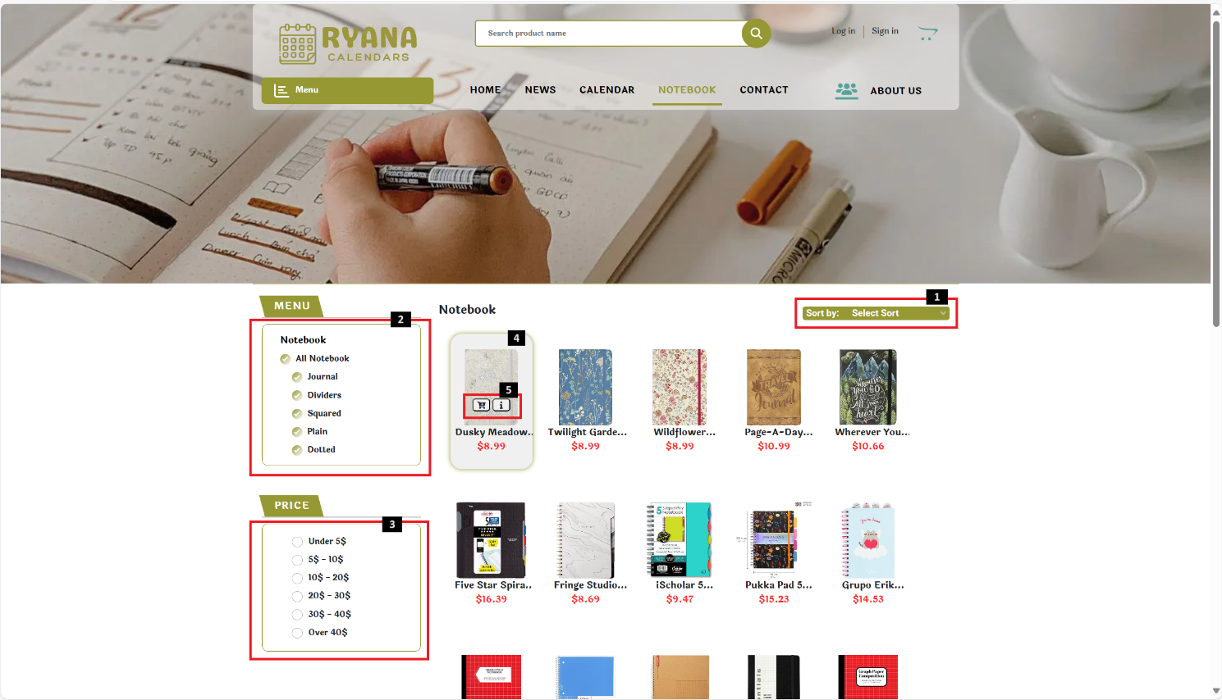

|  |  |  |  |
| --- | --- | --- | --- |
| **No** | **Type** | **Validation** | **Action** |
| 1 | Hover |  | Show sort type |
| 2 | Click |  | Sort by Notebook’s category |
| 3 | Click |  | Sort by price |
| 4 | Hover/Click |  | Show 2 button/Navigation to Product detail |
| 5 | Click |  | * Add to cart * Show Product detail modal |

## Download

The Download function is used to download details of each product and all products.

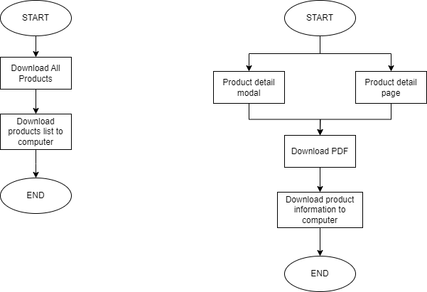

*Download details of each product.*

**

*Download details of all products.*

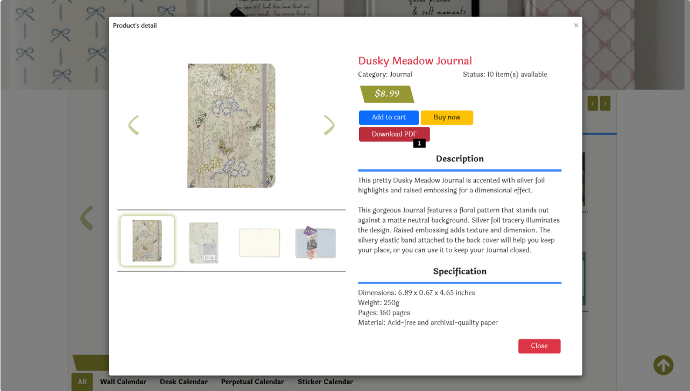

|  |  |  |  |
| --- | --- | --- | --- |
| **No** | **Type** | **Validation** | **Action** |
| 1 | Click |  | Download details of each product. |

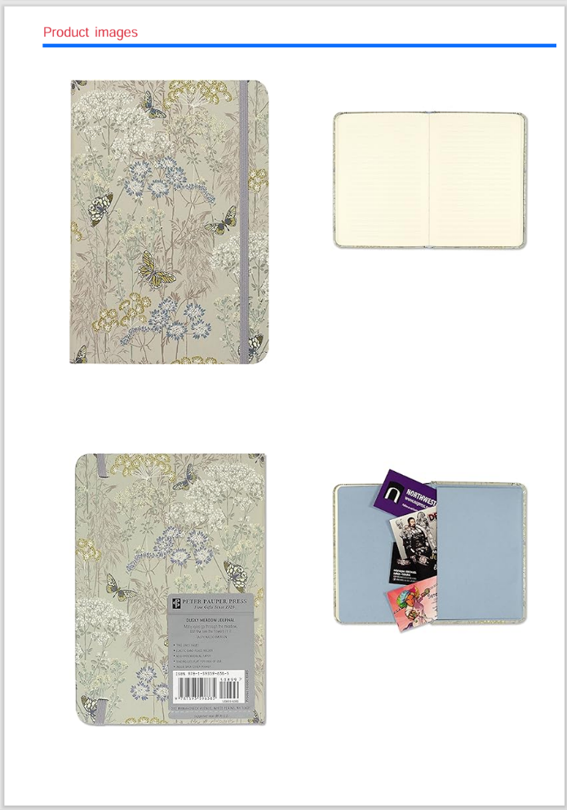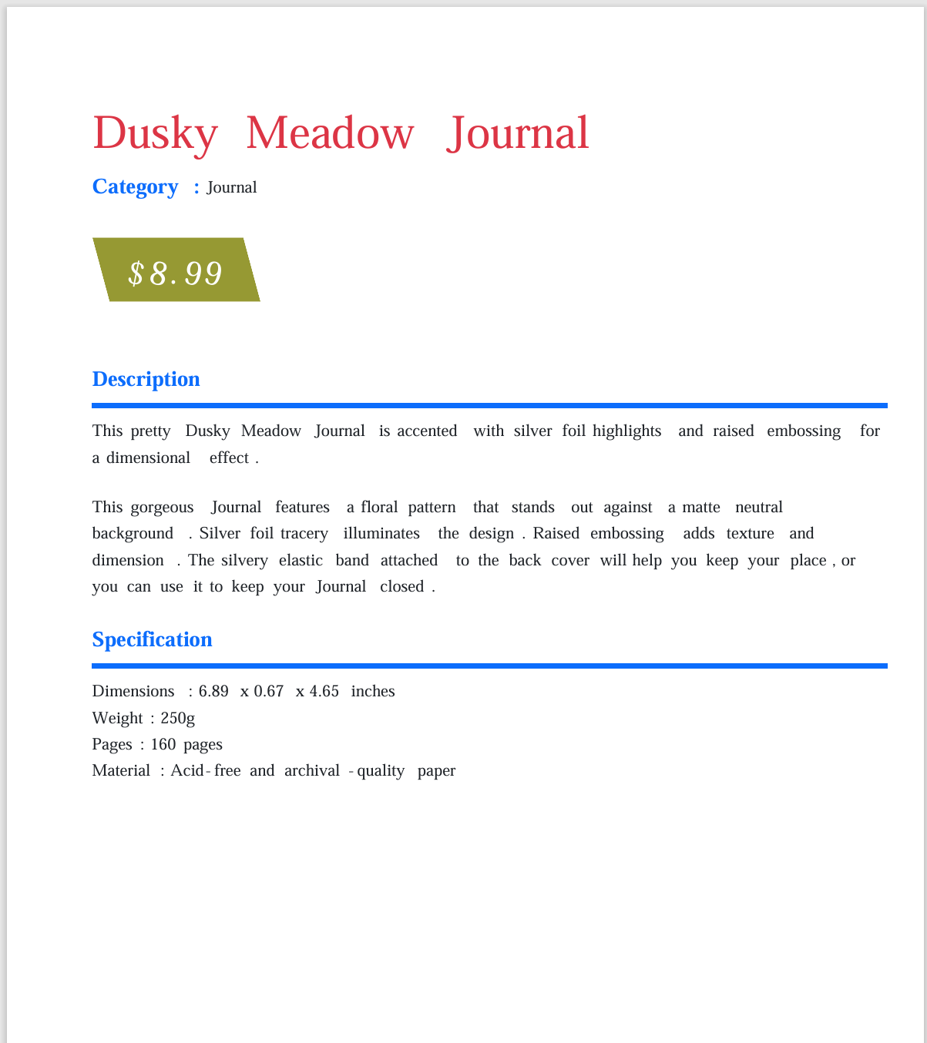

Download details of each product consisting of 2 pages. One page contains product details and the other page contains product images.

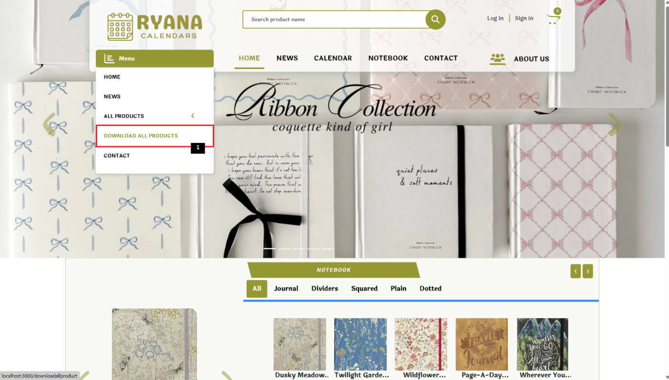

|  |  |  |  |
| --- | --- | --- | --- |
| **No** | **Type** | **Validation** | **Action** |
| 1 | Click |  | Download details of all product. |

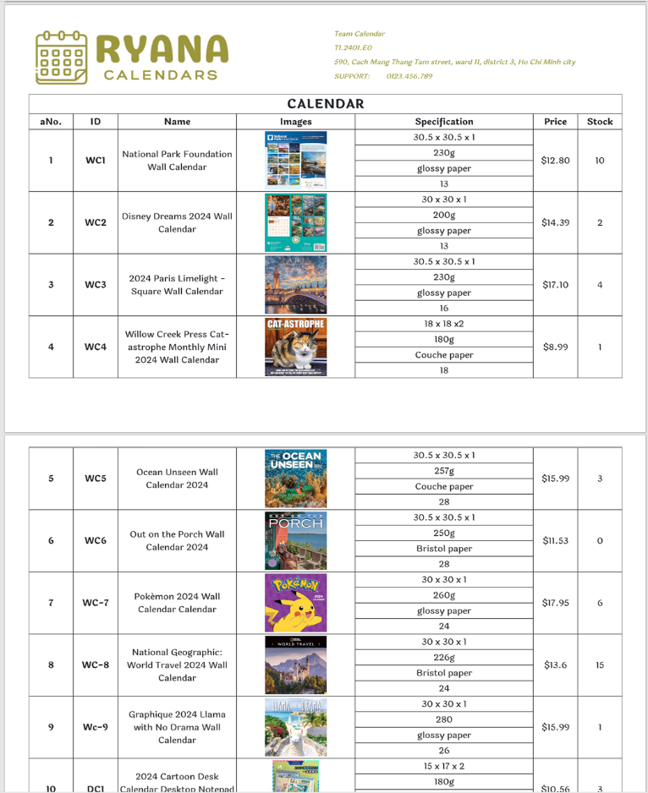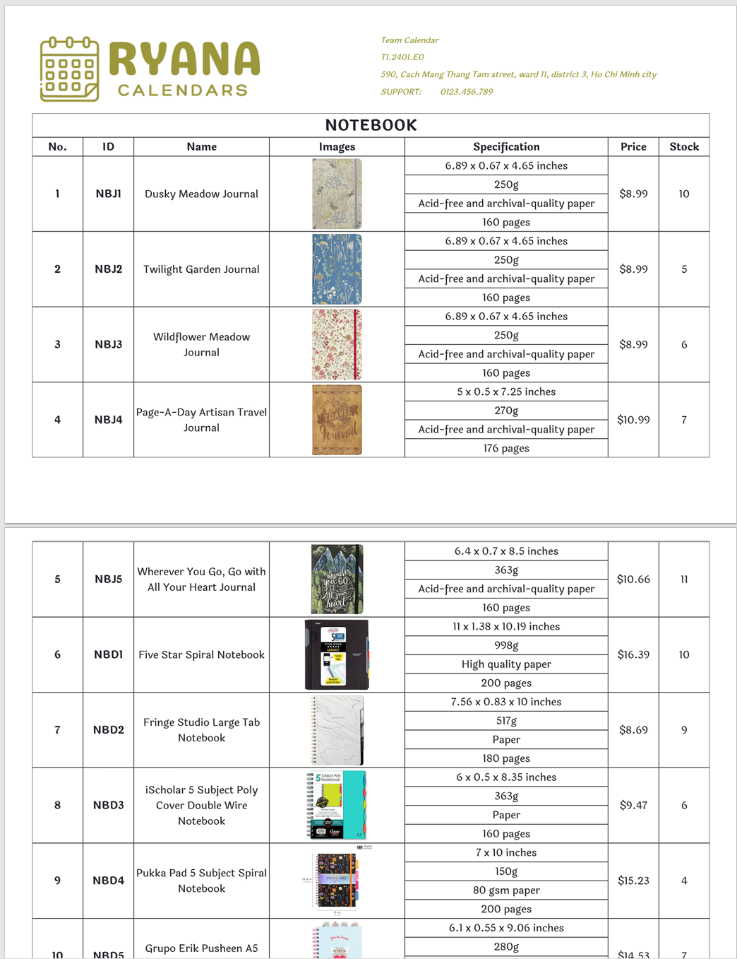

Download details of all product consisting of 10 pages.

## Contact Page

The Contact Us page is used to view contact information for Ryana Calendars, information and locations of Ryana Calendar’s company on the map, and user comments or complaints.

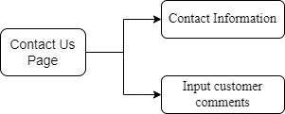

*Contact Us Page diagram.*

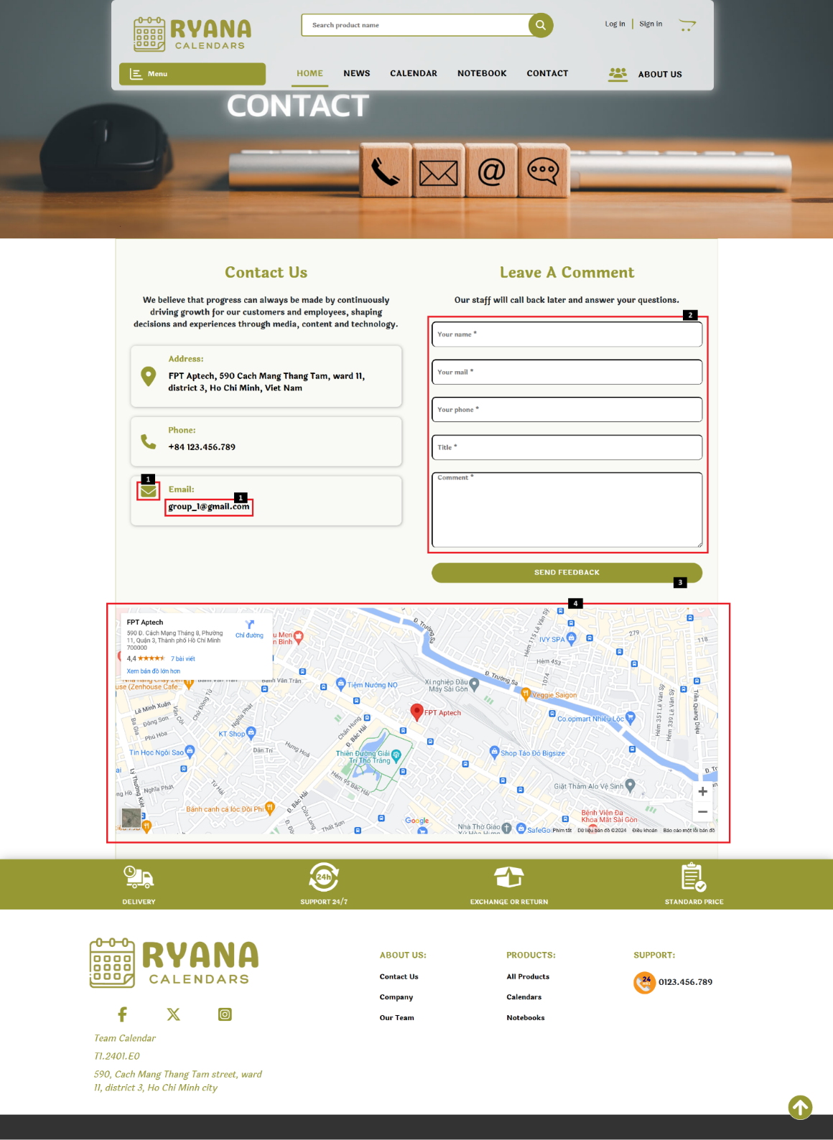

|  |  |  |  |
| --- | --- | --- | --- |
| **No** | **Type** | **Validation** | **Action** |
| 1 | Click |  | Enter local email client for customer ton send an email |
| 2 | Text | All field is required. | Input customer information and feedback |
| 3 | Click |  | Send Feedback |
| 4 |  |  | Ryana Calendar company geolocation |

## News Page and News Page Detail

### News Page

News about history of calendar, daily life advice, traveling tips

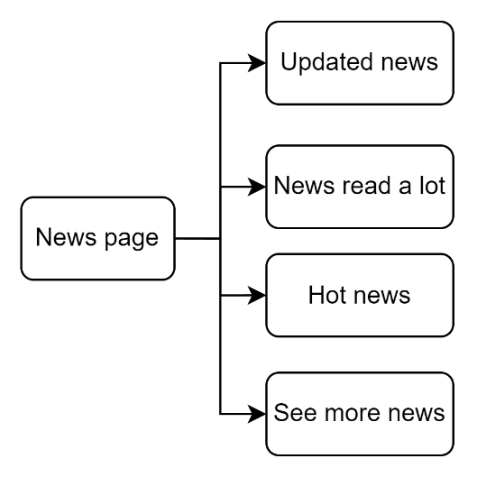

*News Page diagram.*

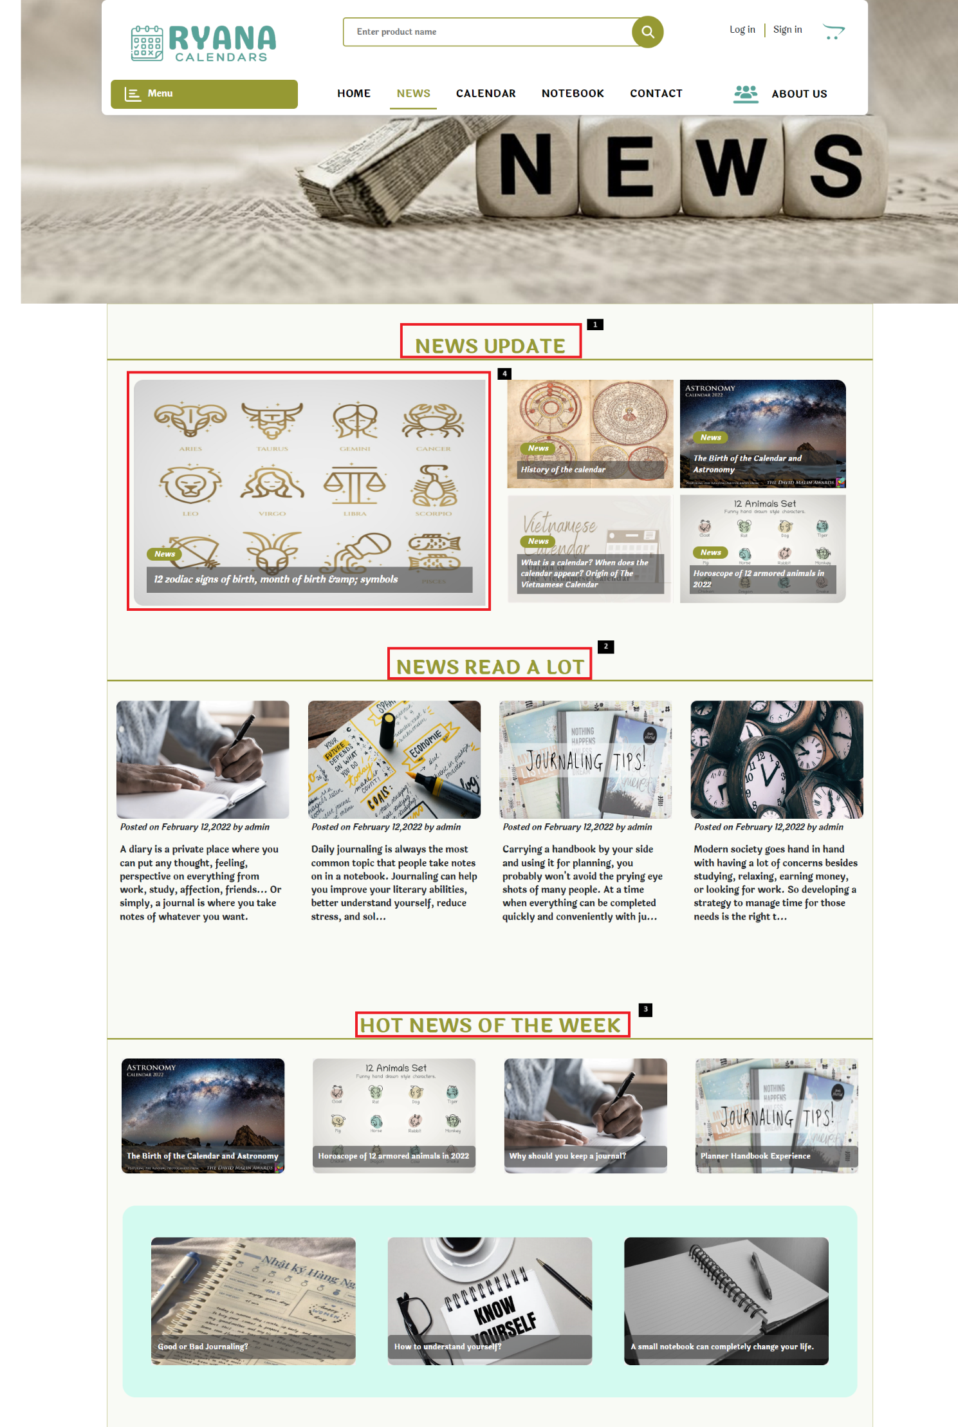

|  |  |  |  |
| --- | --- | --- | --- |
| **No** | **Type** | **Validation** | **Action** |
| 1 |  |  | Latest update news |
| 2 |  |  | News with the most views |
| 3 |  |  | Most viewed news of the week |
| 4 | Click |  | See more news |

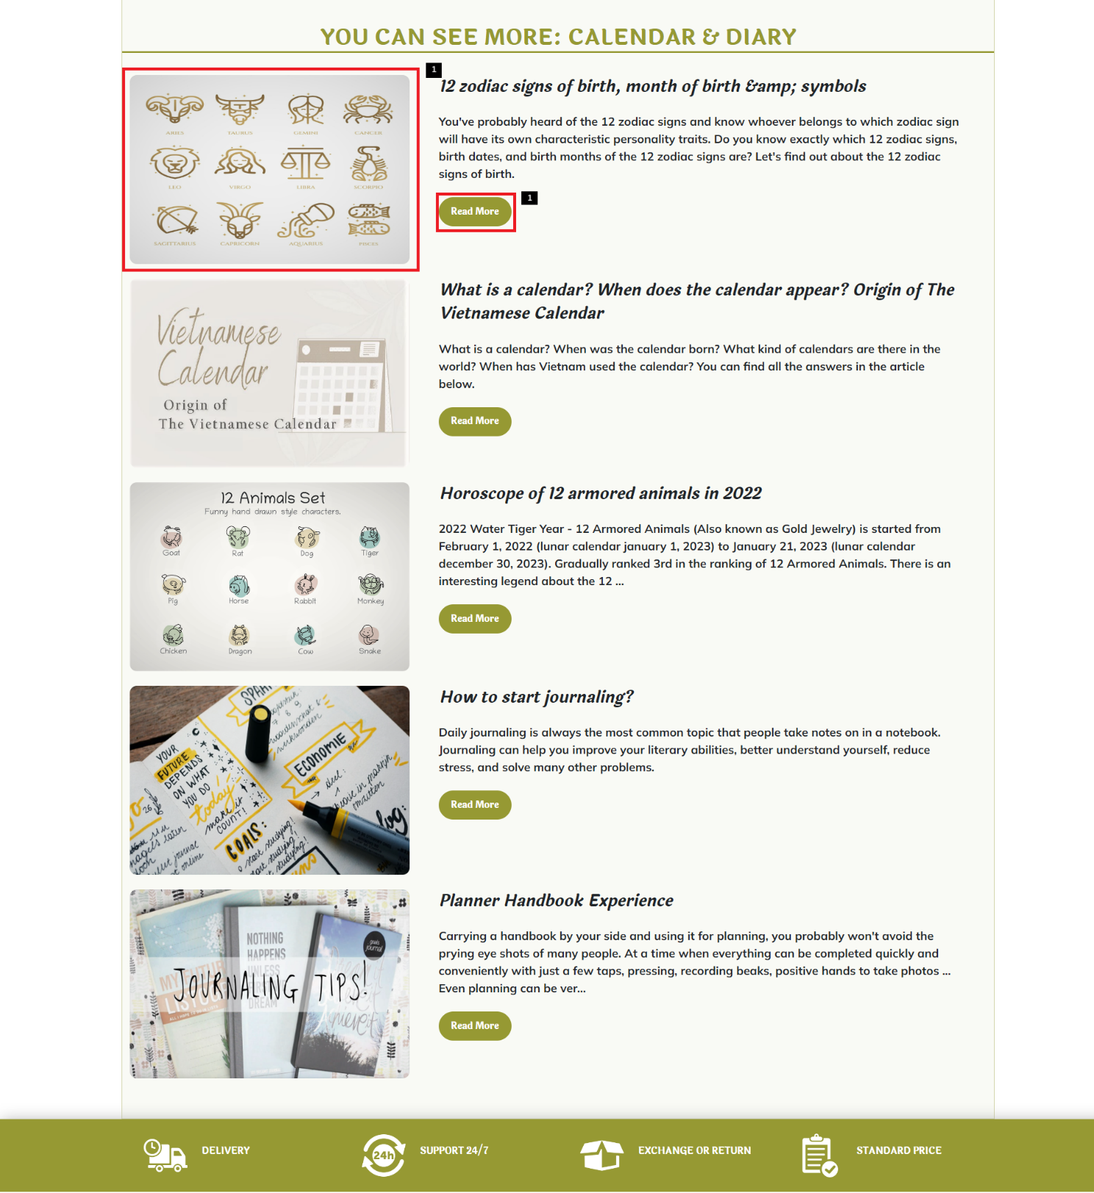

|  |  |  |  |
| --- | --- | --- | --- |
| **No** | **Type** | **Validation** | **Action** |
| 1 | Click |  | See more news |

### News Page Content

The News Page Content is used to view all that news and and suggest related news and news you might like

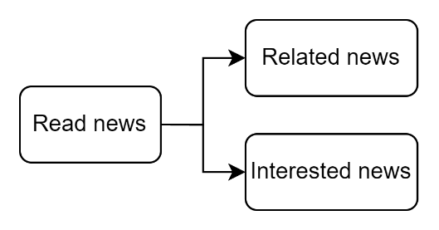

*News Page Content diagram.*

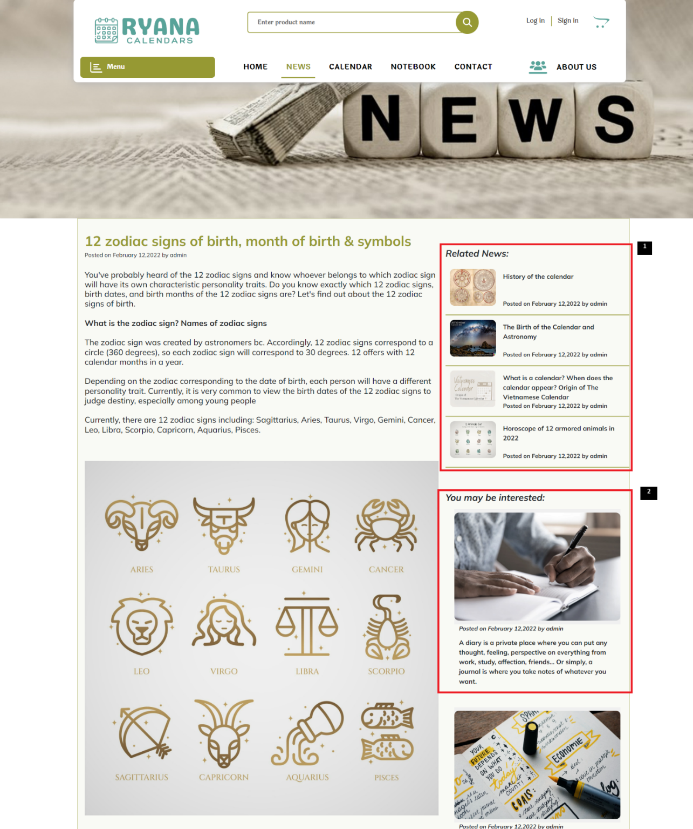

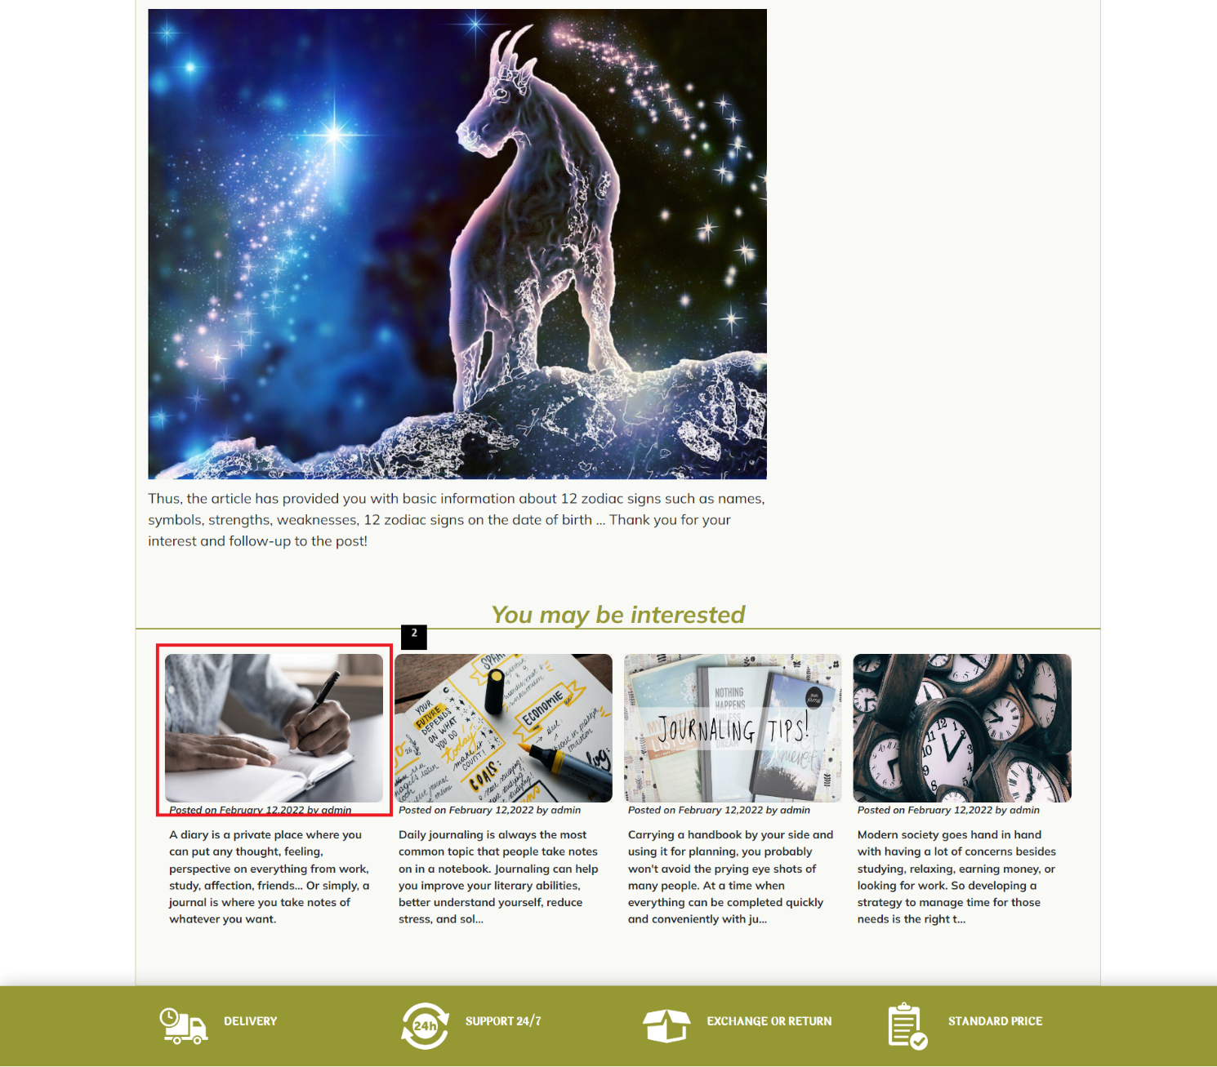

|  |  |  |  |
| --- | --- | --- | --- |
| **No** | **Type** | **Validation** | **Action** |
| 1 | Click |  | See other news have the same topic |
| 2 | Click |  | See news you may be interested |

## About Us Page

The About Us page is used to showcase and display information about members of our team.

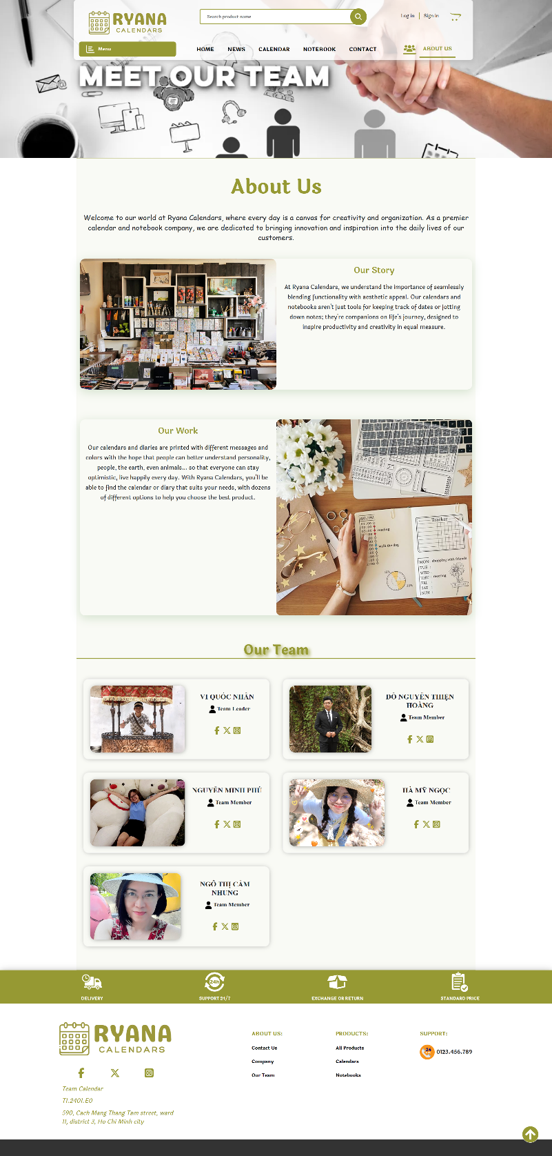

## Responsive Web Page

All Ryana Calendars page (home, product, product detail, cart, news, about us, …)

are responsive in 3 sizes: mobile, tablet, laptop:

* Mobile format: width <= 768px
* Tablet format: 768px<=width<=992px
* Laptop format: width>=1200px

**Below are some responsive example images:**

### Home Page

#### Mobile

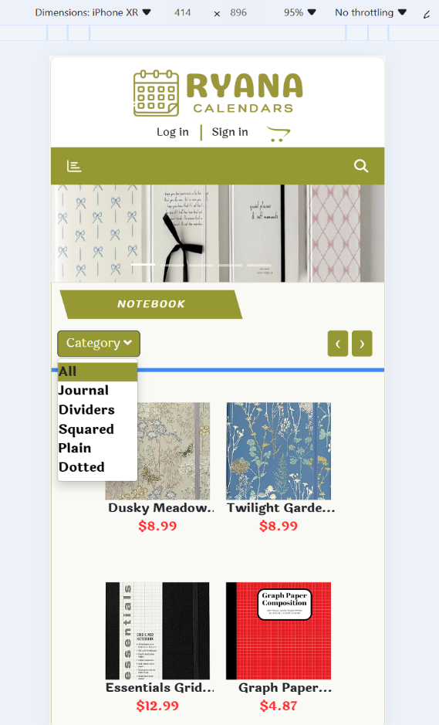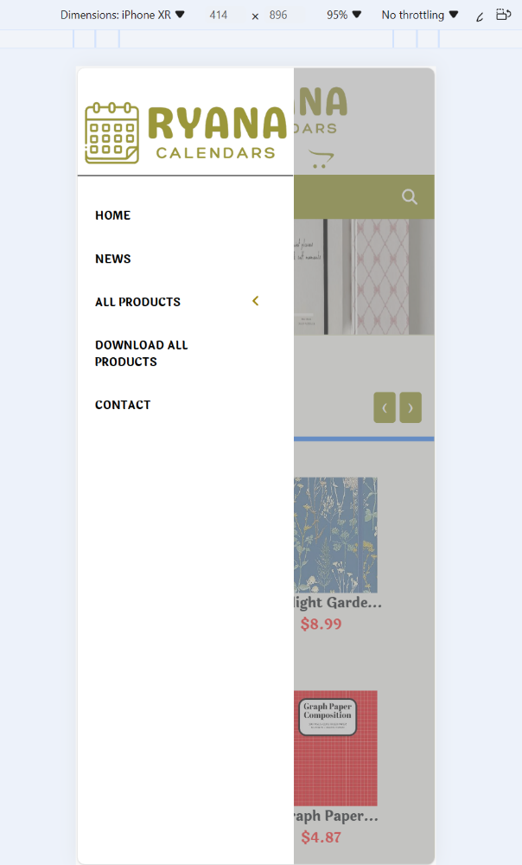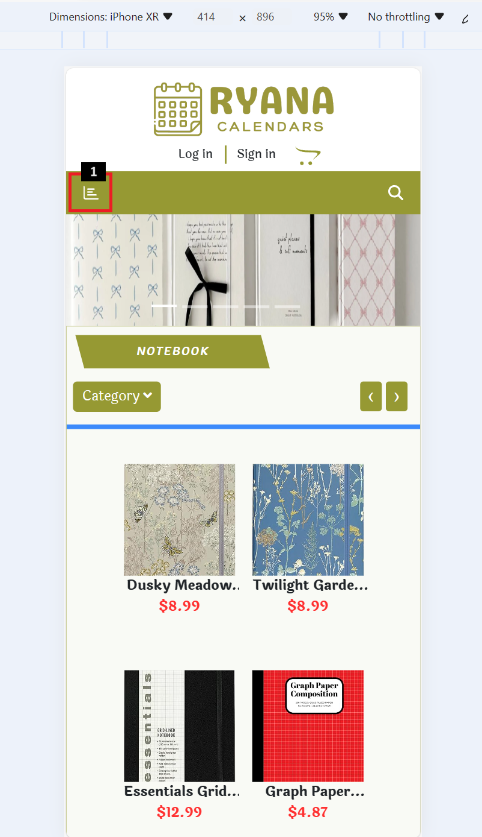

|  |  |  |  |
| --- | --- | --- | --- |
| **No** | **Type** | **Validation** | **Action** |
| 1 | Click |  | Show modal of menu |

#### Tablet

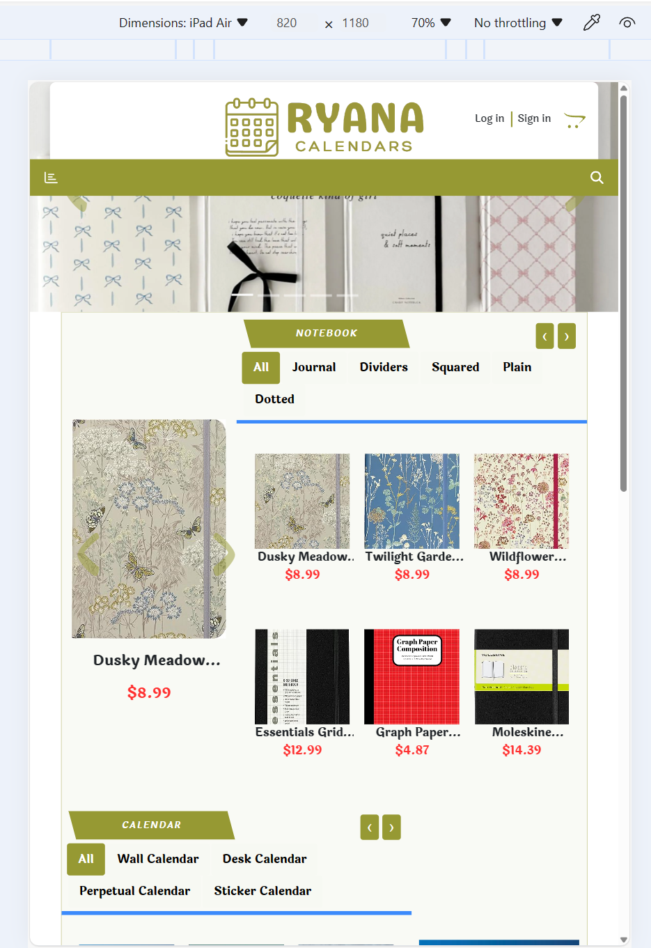

#### Laptop

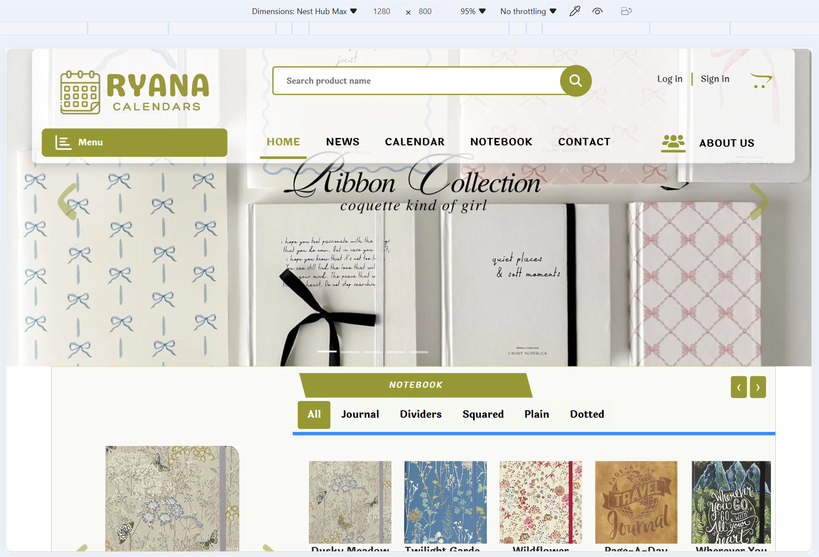

### News Page

#### Mobile

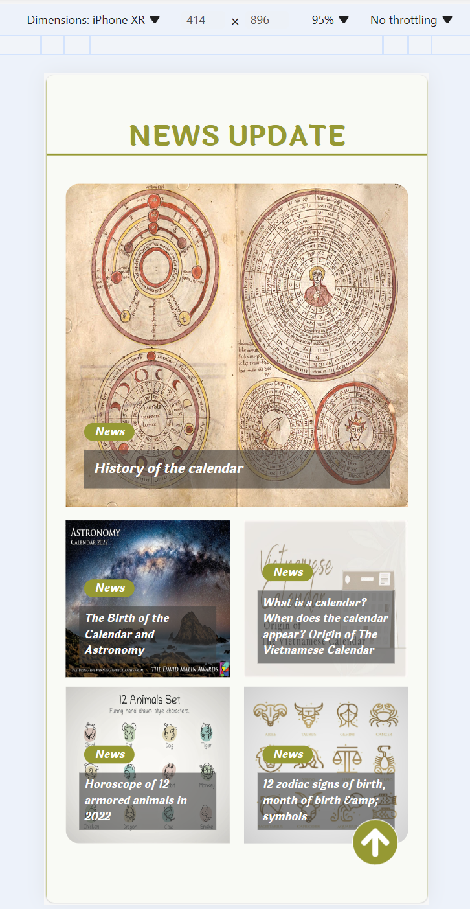

#### Tablet

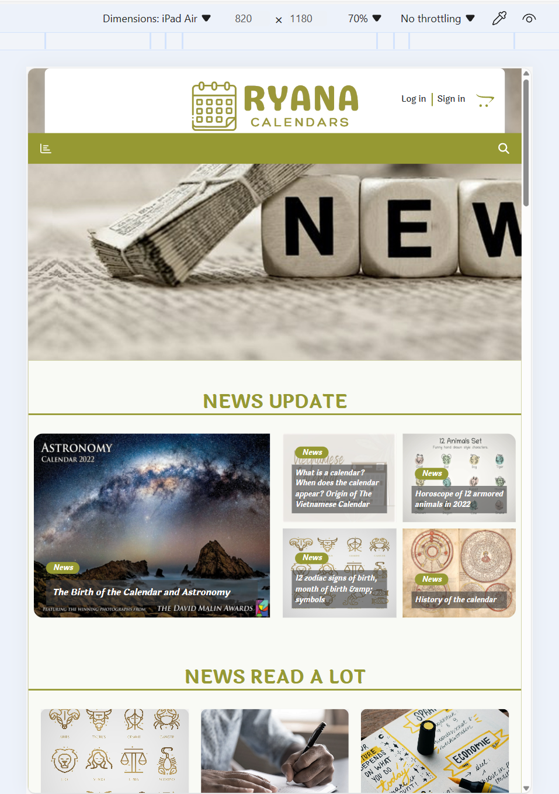

#### Laptop

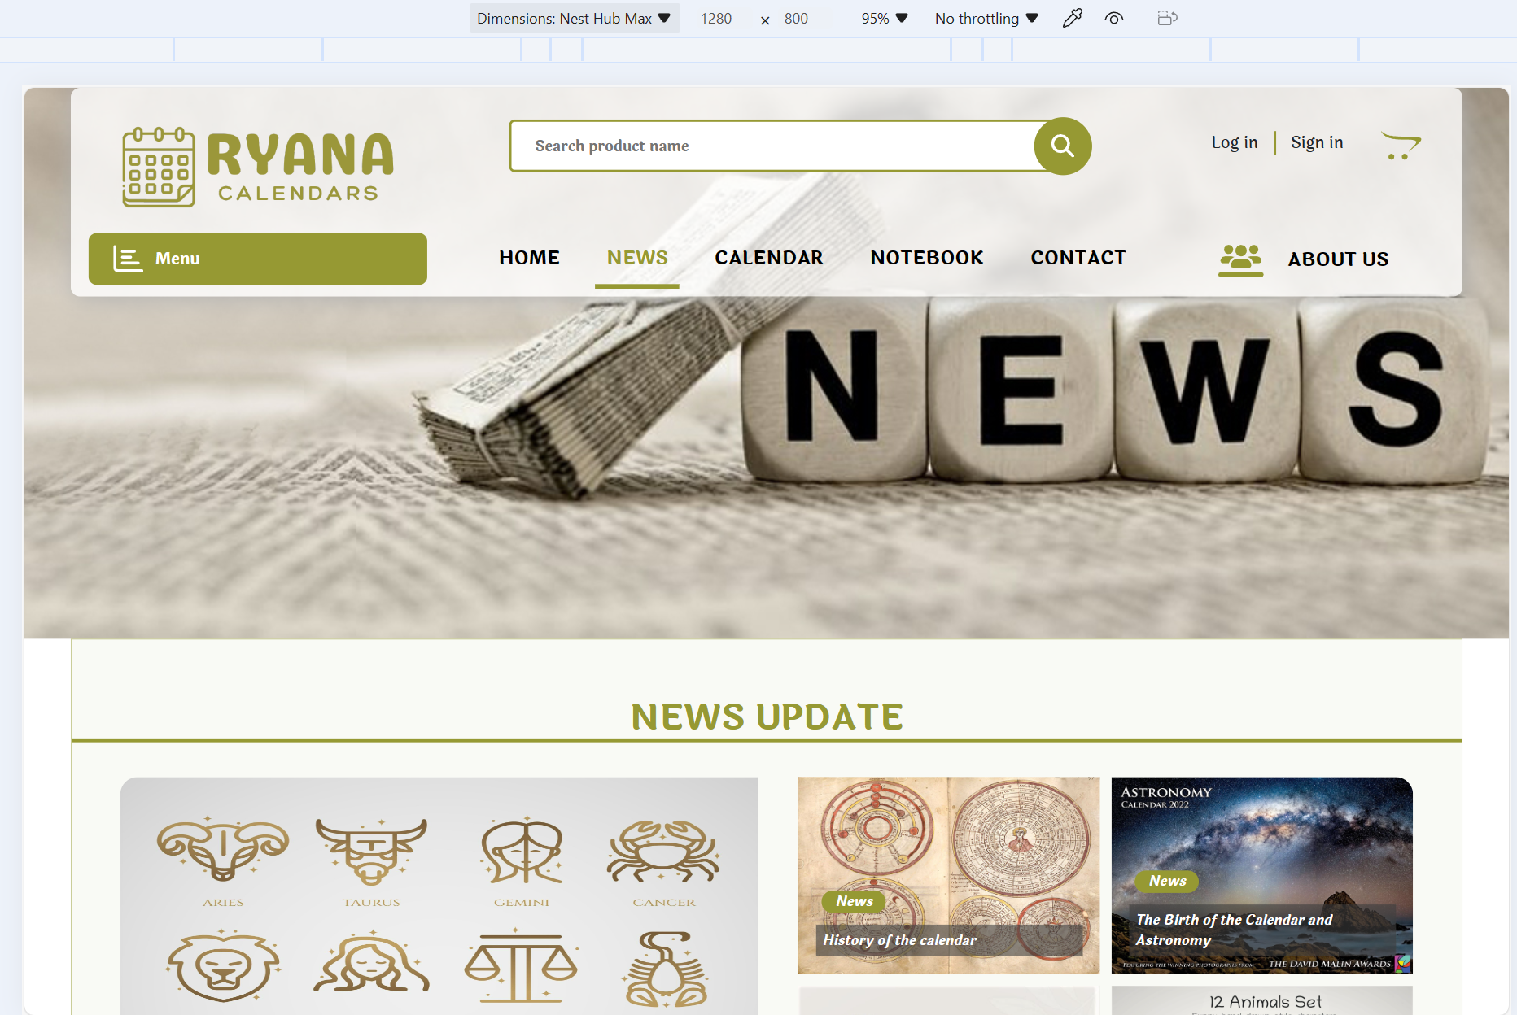

### All Product, Calendar, Notebook Page

#### Mobile

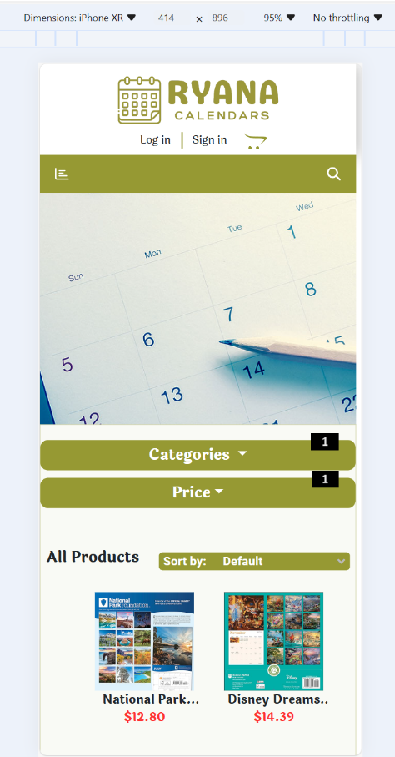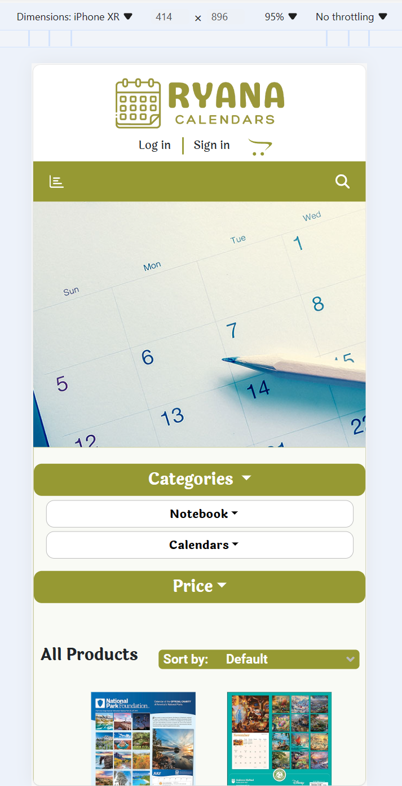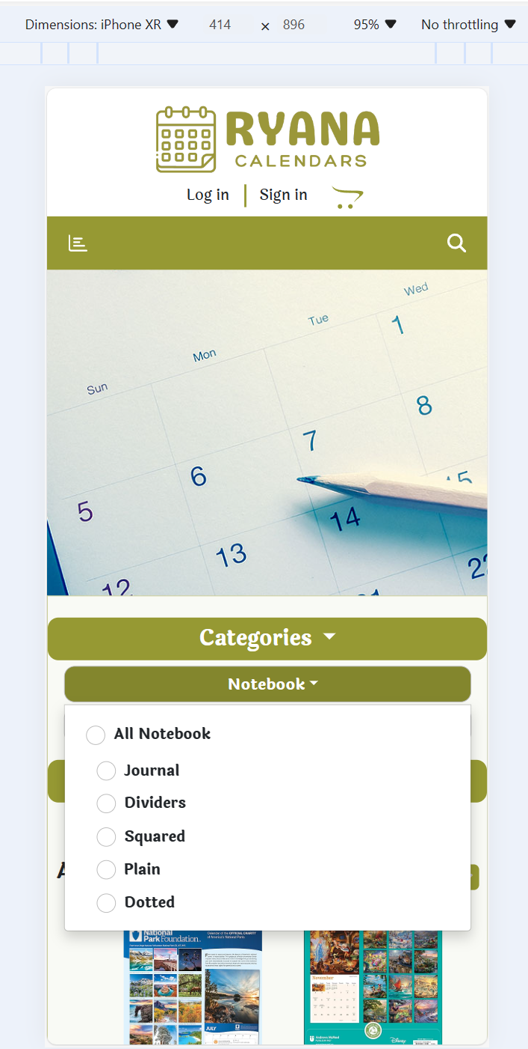

|  |  |  |  |
| --- | --- | --- | --- |
| **No** | **Type** | **Validation** | **Action** |
| 1 | Click |  | Show list filter by categories and price |

#### Tablet

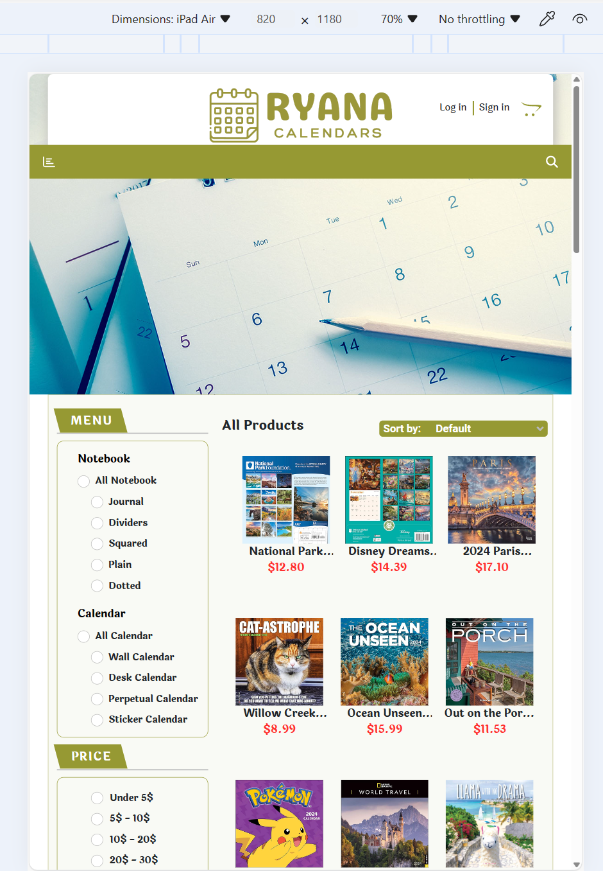

#### Laptop

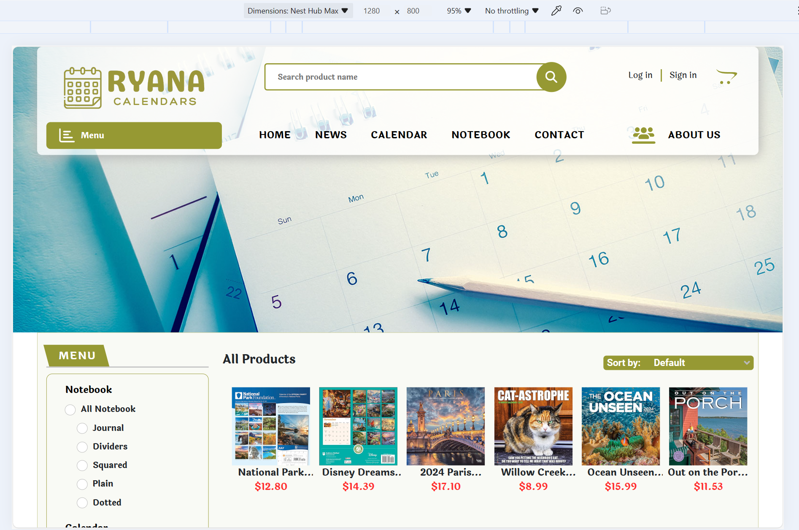

### Contact Page

#### Mobile

#### Tablet

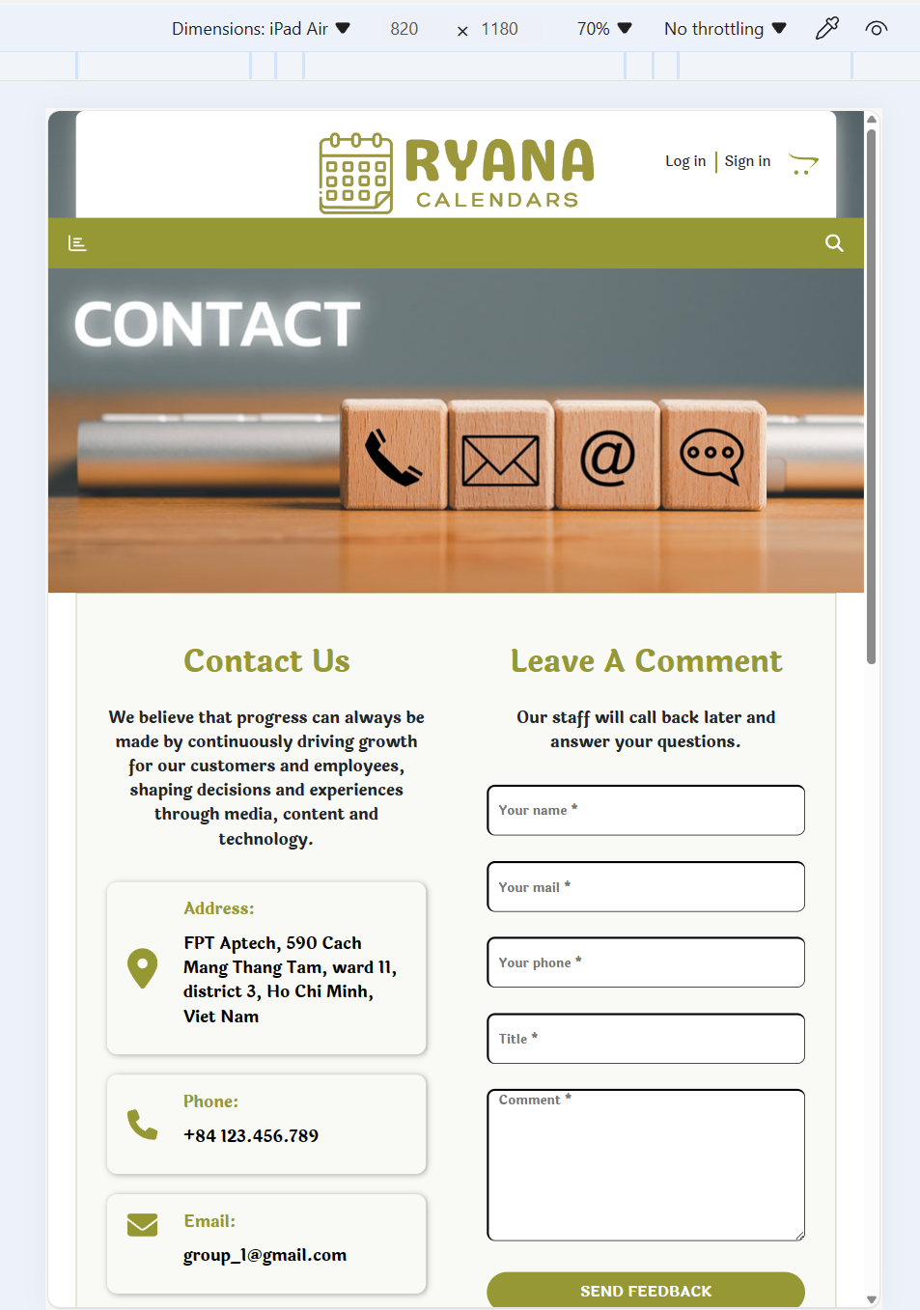

#### Laptop

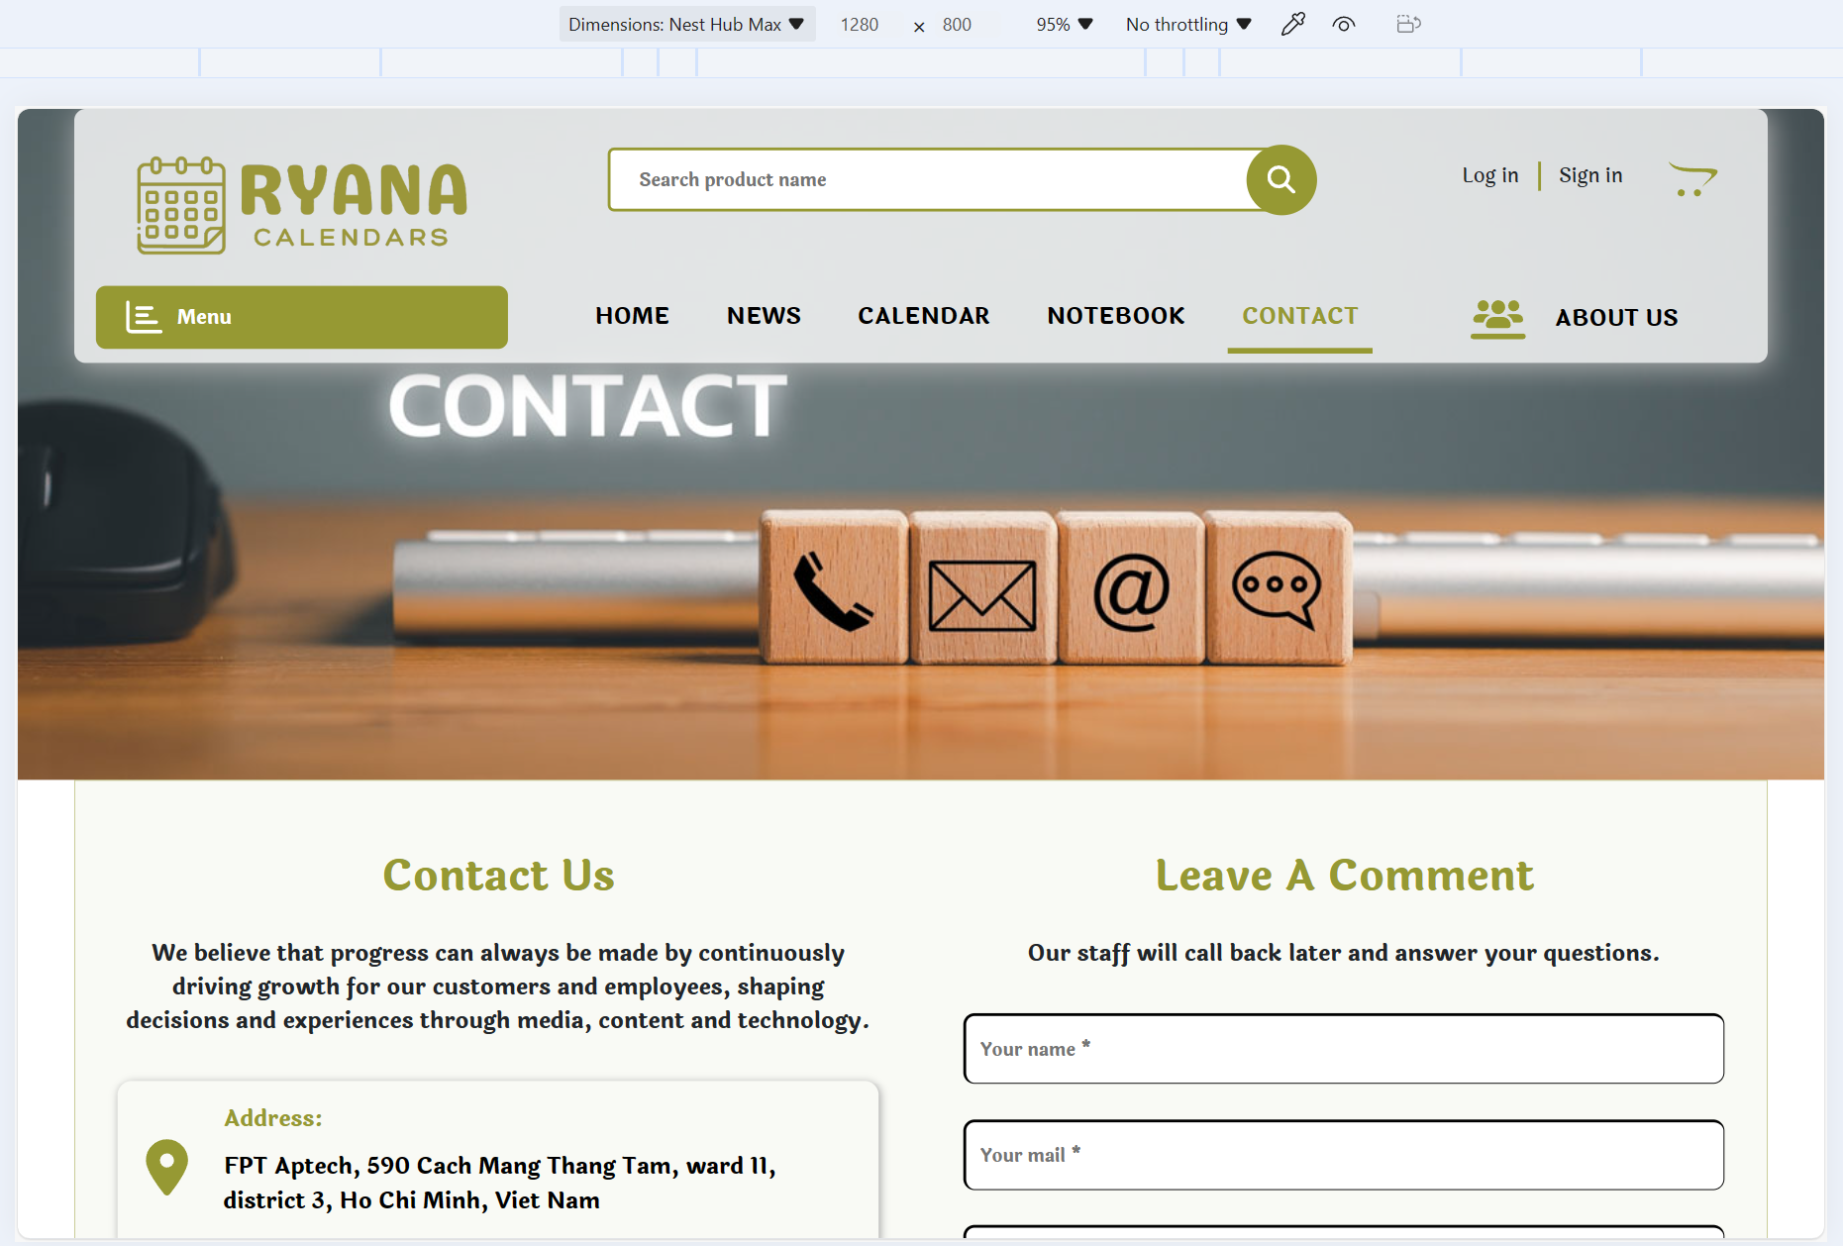

# Task Sheet

|  |  |  |  |  |
| --- | --- | --- | --- | --- |
| **No.** | **TASK / MEMBER** | | | **Status** |
| 1 | Header | VI QUỐC NHẪN/  HÀ MỸ NGỌC | Logo | 100% |
| Search box | 100% |
| Navbar | 100% |
| Menu | 100% |
| Cart Icon | 100% |
| Responsive | 100% |
| 2 | Footer | VI QUỐC NHẪN/  HÀ MỸ NGỌC | Logo | 100% |
| Information | 100% |
| Link tab | 100% |
| Responsive | 100% |
| 3 | Home page | ĐỖ NGUYỄN THIỆN HOÀNG/  NGUYỄN MINH PHÚ | Show products | 100% |
| Animation | 100% |
| Product card | 100% |
| Add to cart | 100% |
| Product detail modal | 100% |
| Product detail page | 100% |
| Responsive | 100% |
| 4 | Download | ĐỖ NGUYỄN THIỆN HOÀNG | Download detail product | 100% |
| Download all products | 100% |
| 5 | Search Page | VI QUỐC NHẪN/  HÀ MỸ NGỌC | Search product by name | 100% |
| Number of products found | 100% |
| Responsive | 100% |
| 6 | All products page/ Calendar page/ Notebook page | VI QUỐC NHẪN  NGUYỄN MINH PHÚ  HÀ MỸ NGỌC | Show all products | 100% |
| Filter by product type | 100% |
| Filter by product price | 100% |
| Sort products by name | 100% |
| Sort products by price | 100% |
| Responsive | 100% |
| 7 | News page | VI QUỐC NHẪN/  NGUYỄN MINH PHÚ | Show all news | 100% |
| Read news | 100% |
| Show related news | 100% |
| Responsive | 100% |
| Animation | 100% |
| 8 | Cart page | VI QUỐC NHẪN/  NGUYỄN MINH PHÚ | Show all products in cart | 100% |
| Calculate subprice | 100% |
| Calculate total price | 100% |
| Change quantity | 100% |
| Remove product | 100% |
| Responsive | 100% |
| Animation | 100% |
| 9 | Checkout page | VI QUỐC NHẪN | Order information form | 100% |
| Payment method | 100% |
| Cart list and total price + shipping | 100% |
| Responsive | 100% |
| 10 | Contact page | VI QUỐC NHẪN/  NGUYỄN MINH PHÚ | Contact information | 100% |
| Feedback form | 100% |
| Position of store on map | 100% |
| Responsive | 100% |
| Animation | 100% |
| 11 | About Us page | ĐỖ NGUYỄN THIỆN HOÀNG/  NGUYỄN MINH PHÚ | eProject Subject | 100% |
| Our team | 100% |
| Responsive | 100% |
| Animation | 100% |